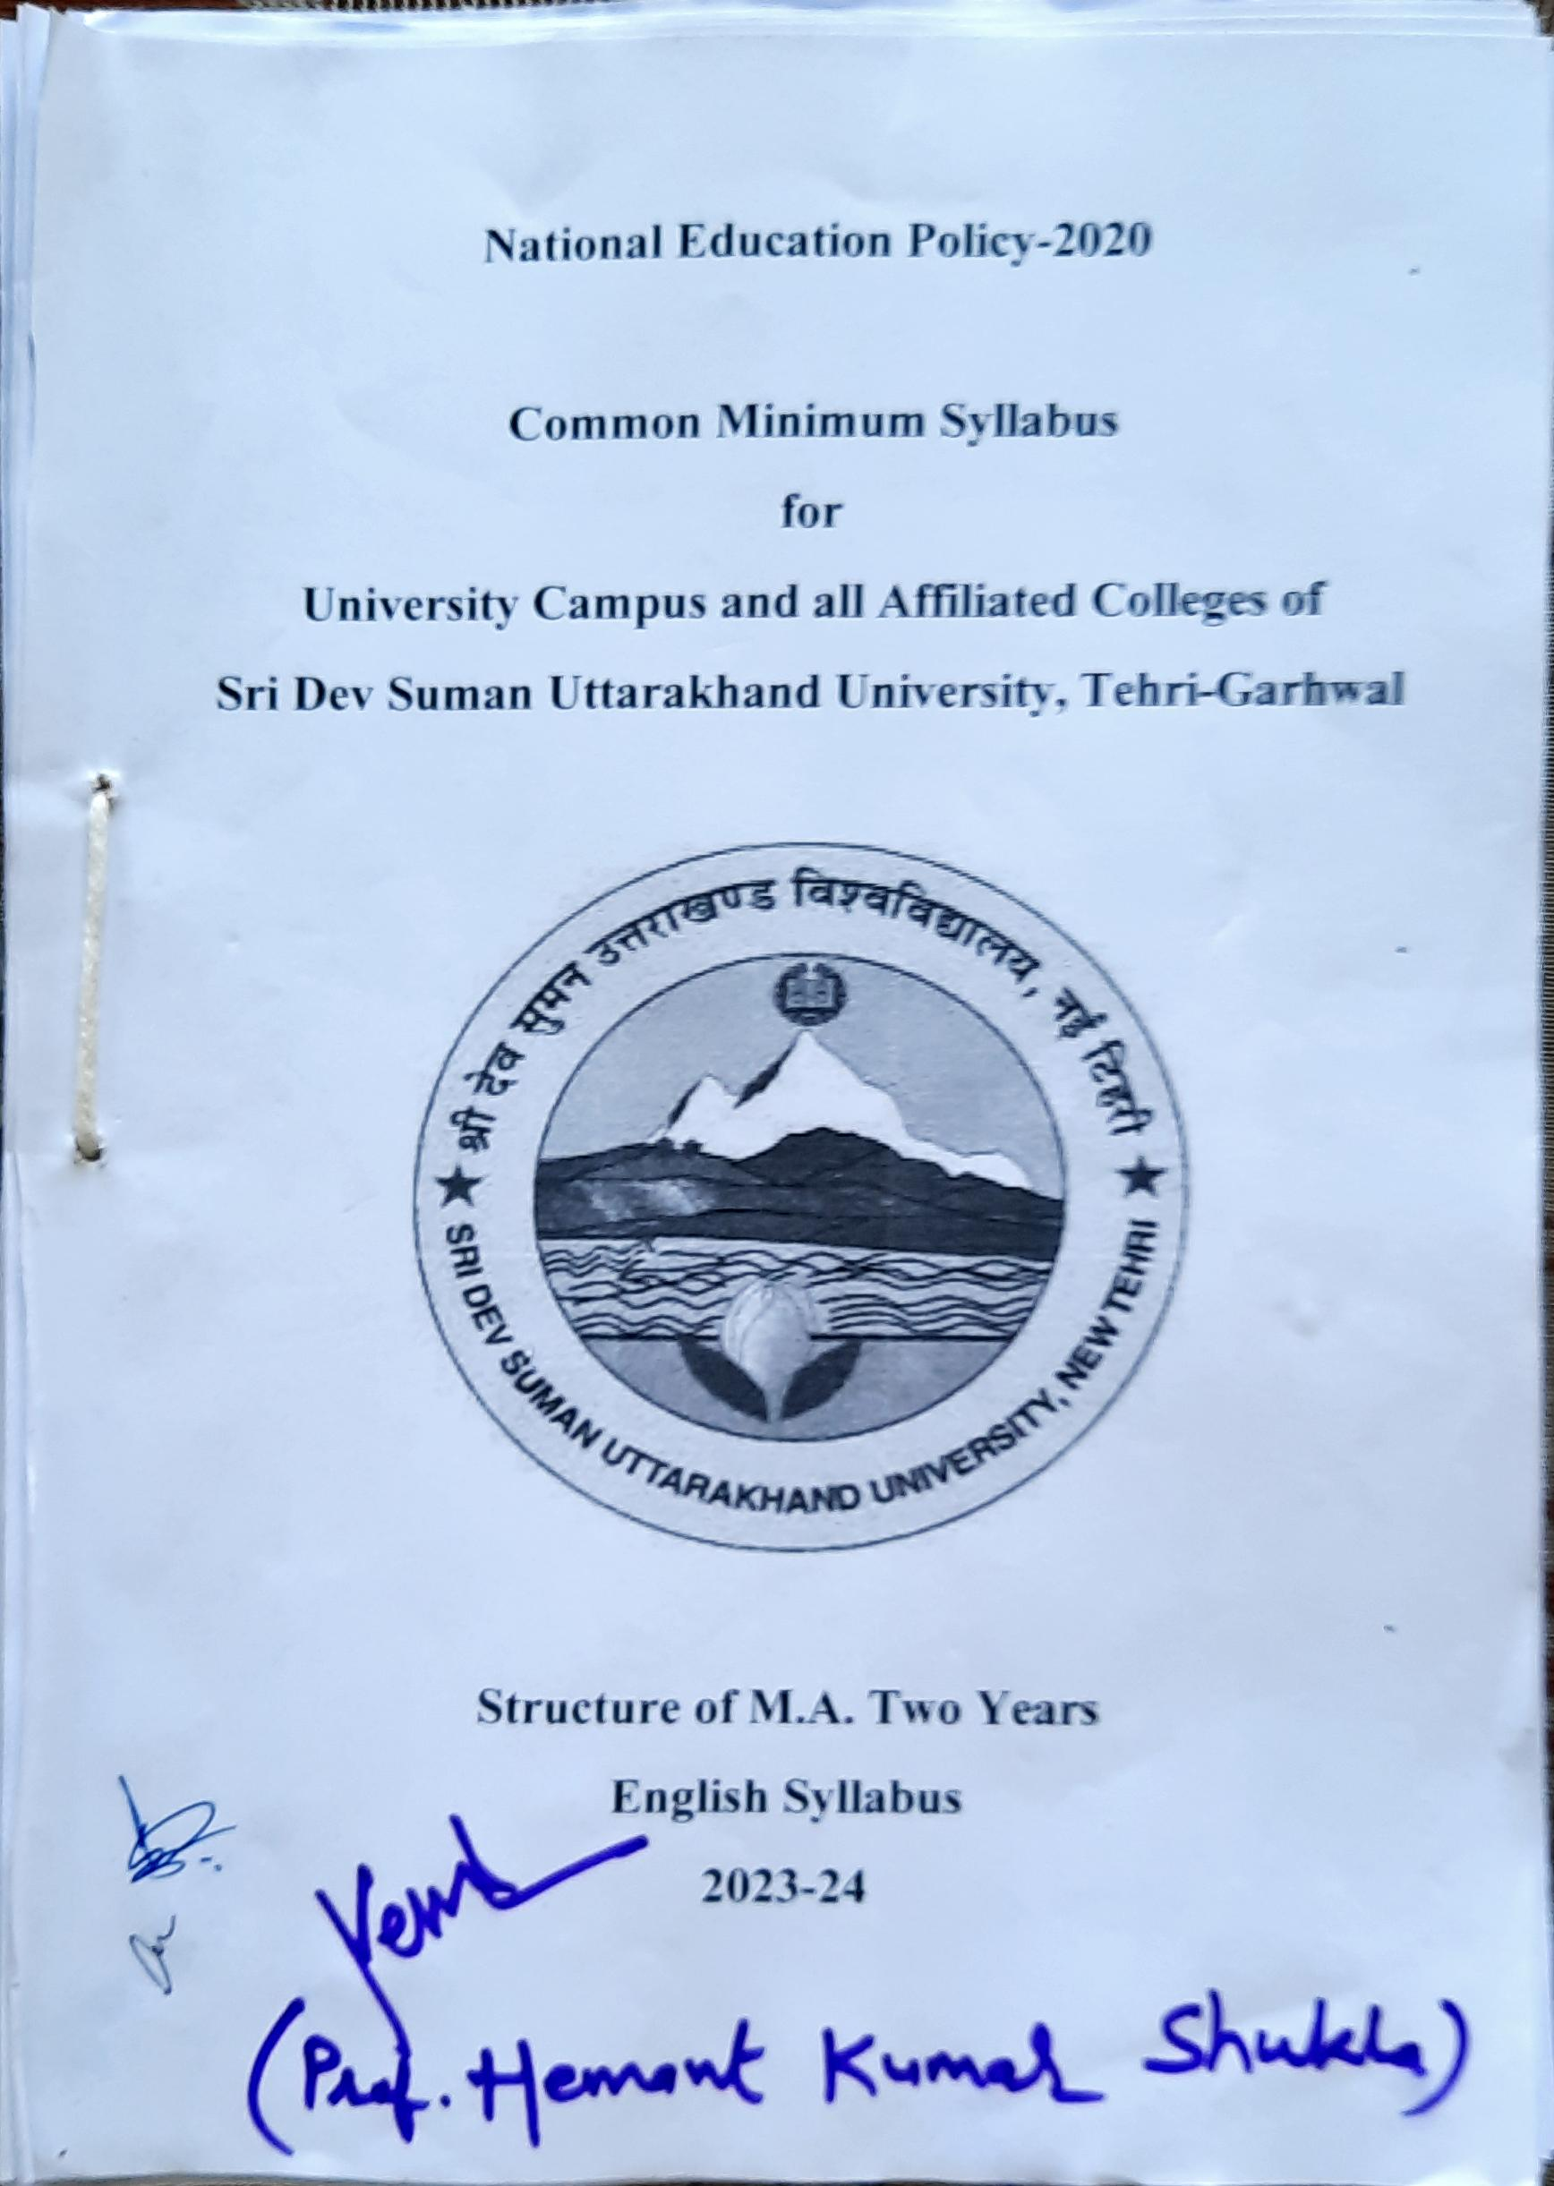

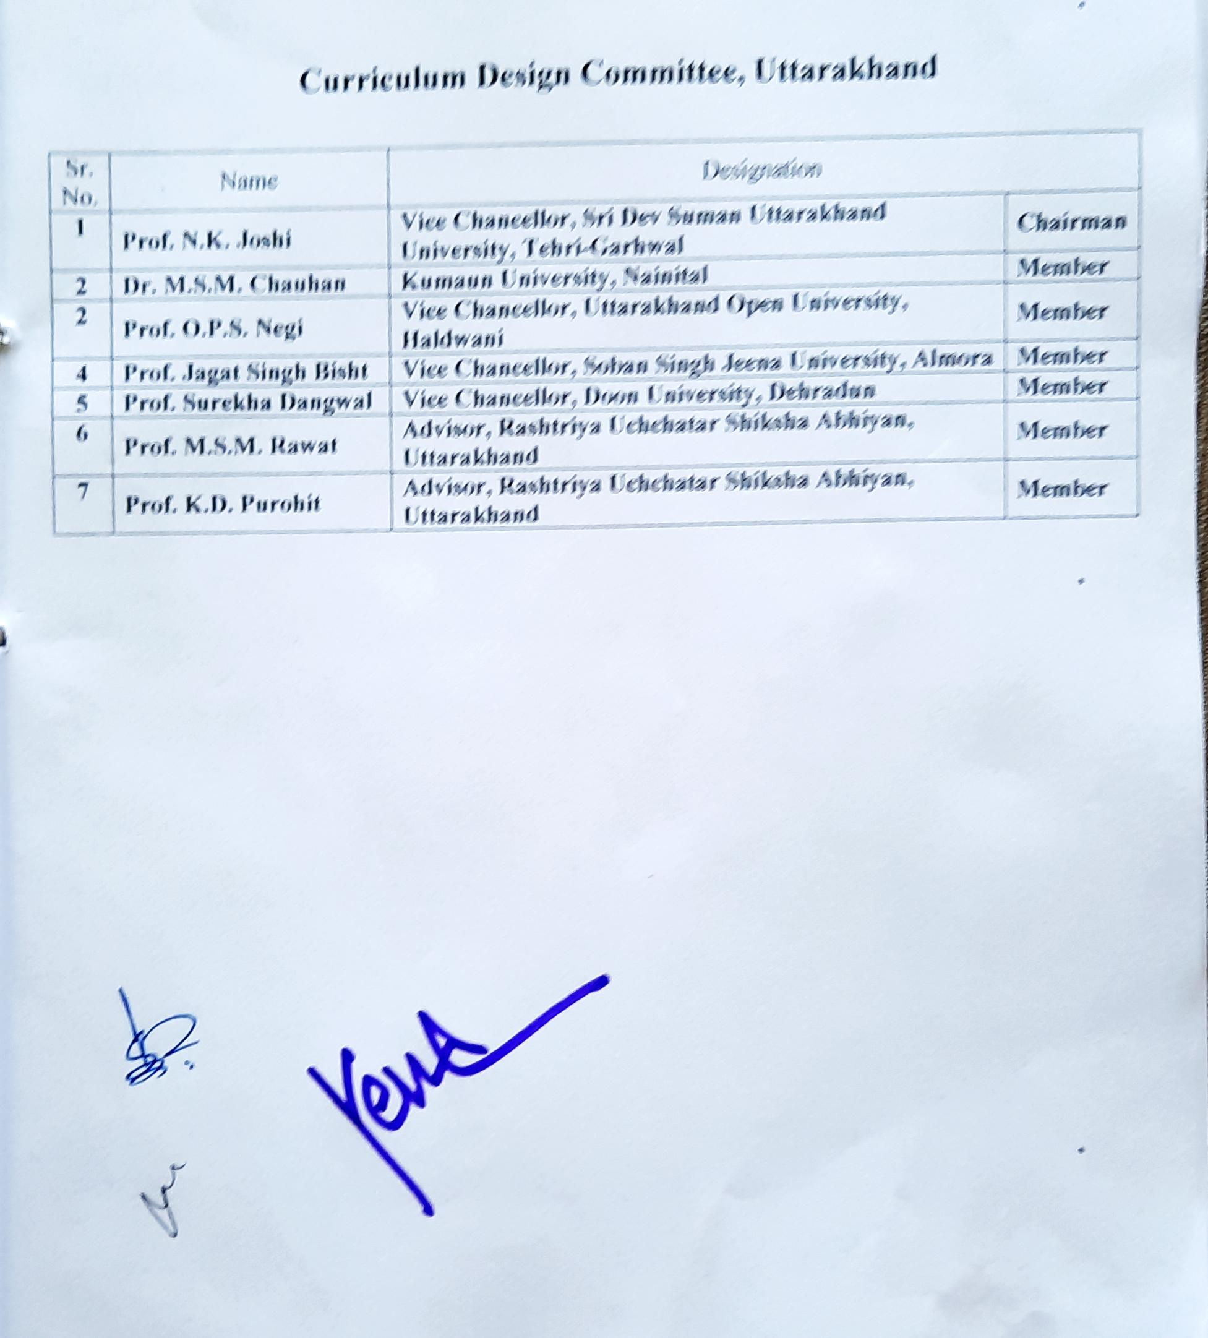

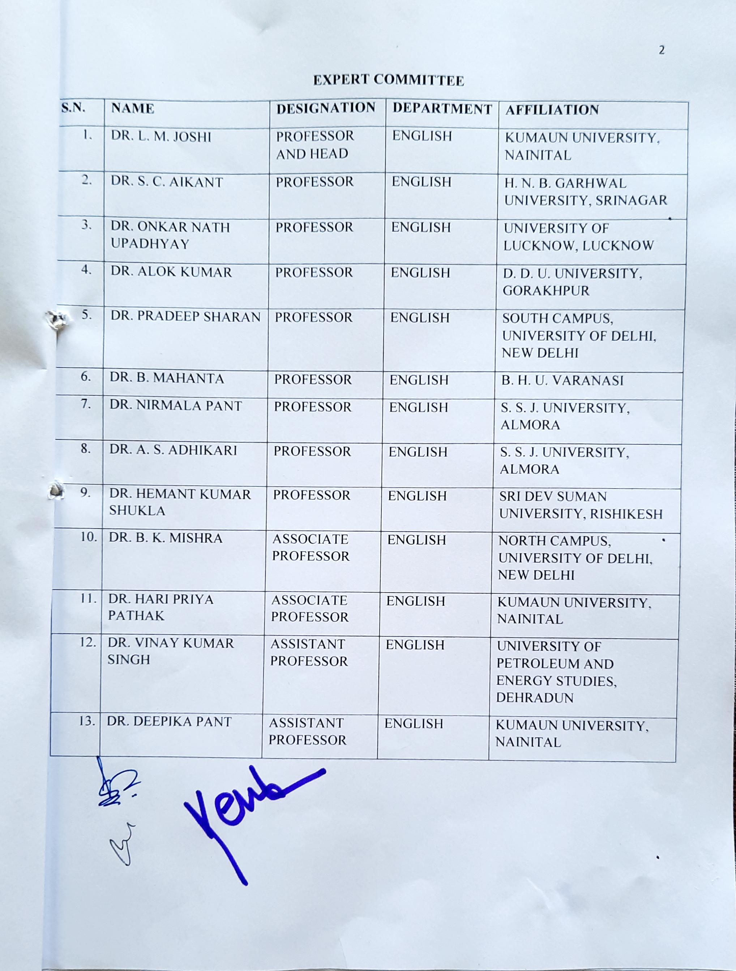

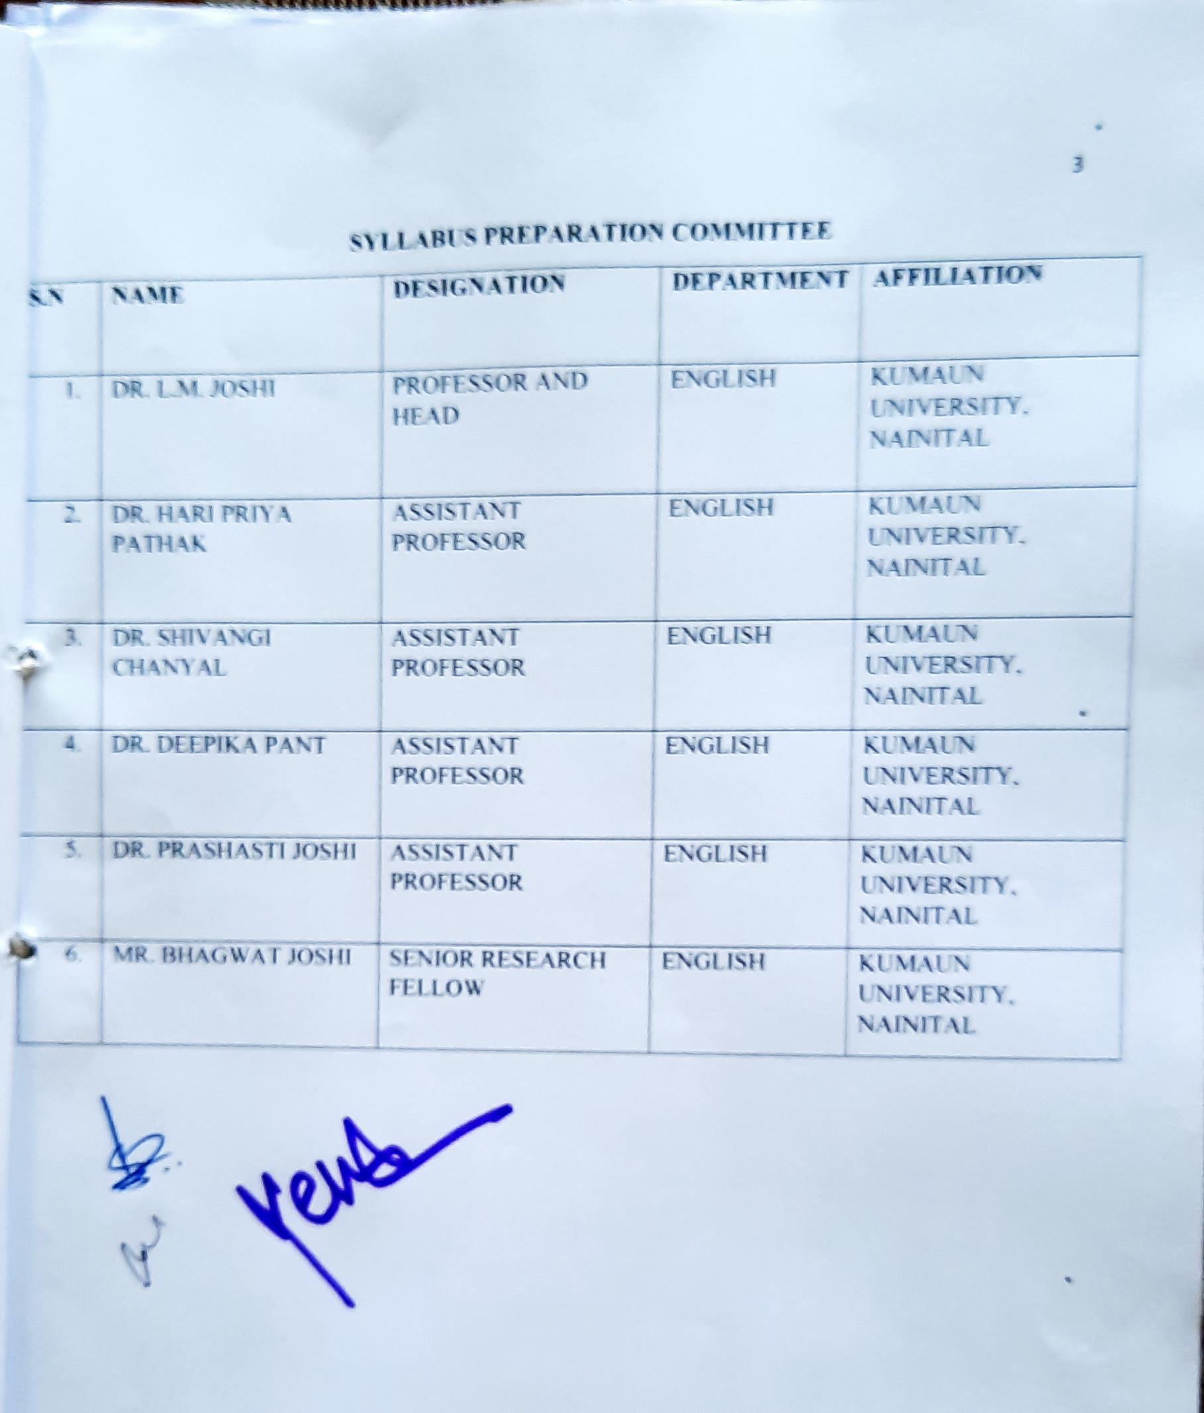

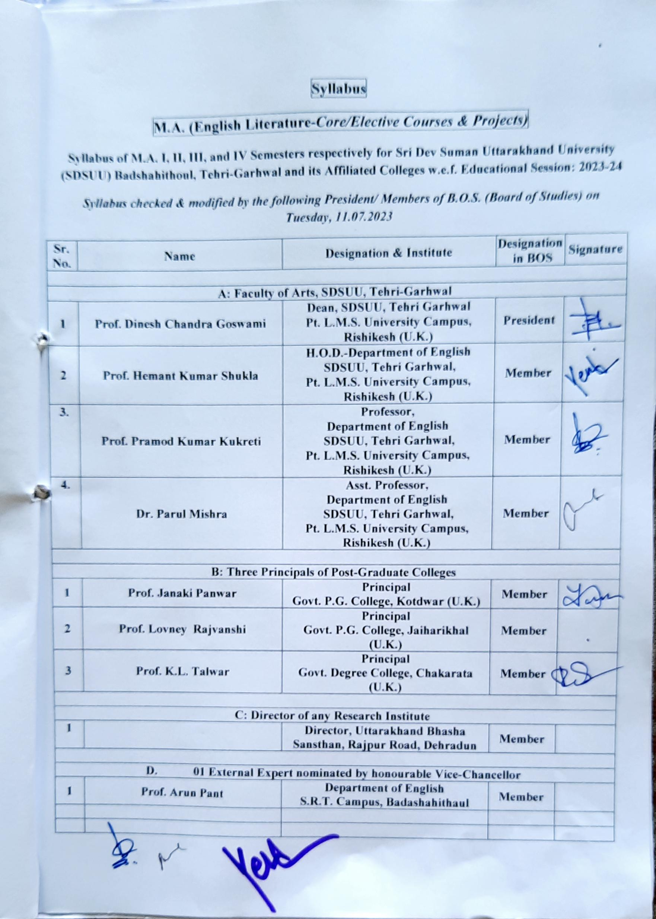

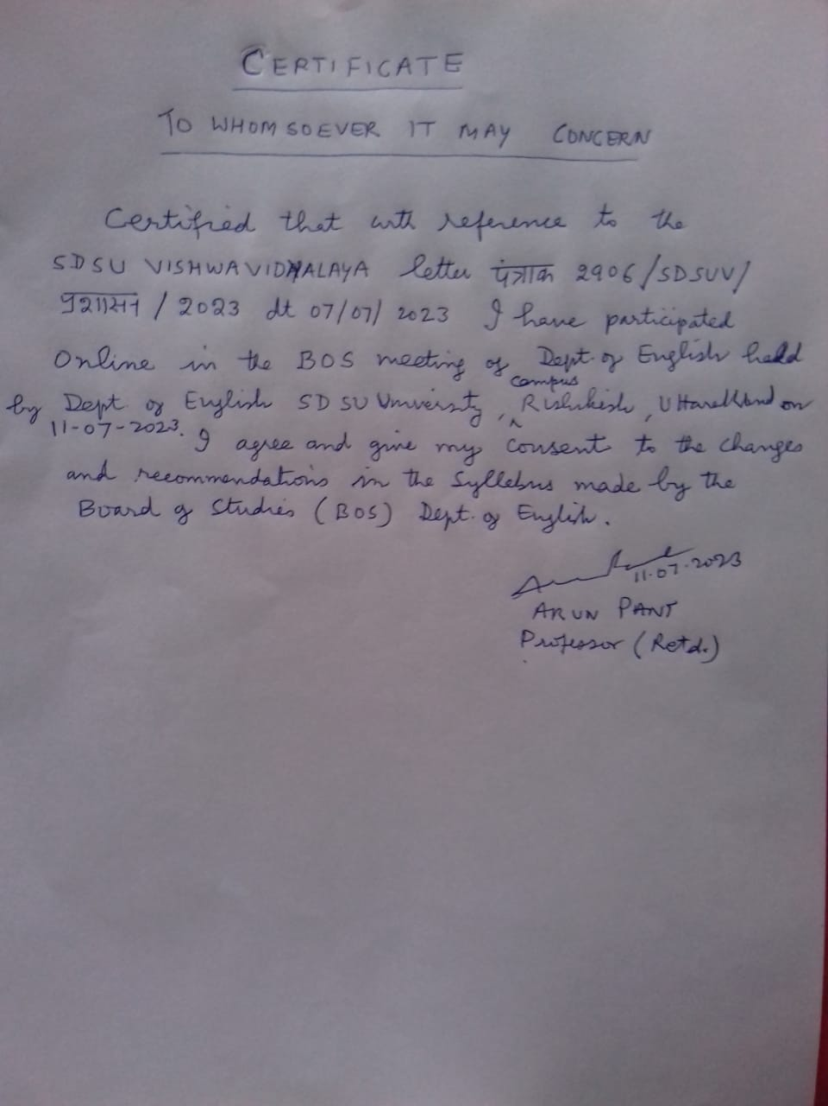

**Note: Students enrolling in M.A. I Semester in the session 2023-24 will follow FYUGP syllabus.**

|  |  |  |  |  |  |
| --- | --- | --- | --- | --- | --- |
| **Semester-wise Titles of the Papers in English** | | | | | |
| **Year** | **Sem.** | **Course Code** | **Paper Title** | **Theory/**  **Practical** | **Credits** |
| **Four Year Undergraduate Programme/Honours Programme /Post Graduation I Year** | | | | | |
|  | VII | **UGENG-(Major Course) MC401** | **English Literature from Chaucer to the Renaissance** | Theory | 5 |
| **UGENG-(Major Course) MC402** | **Seventeenth and Eighteenth Century English Literature** | Theory | 5 |
| **UGENG-(Major Course) MC403** | **English Literature of the Romantic Revival** | Theory | 5 |
| **UGENG-(Major Course) MC404** | **English Literature of the Victorian Era** | Theory | 5 |
|  | **UGENG-(Research Project) RP405** | **Research Methods for English Studies** | Theory | 4 |
| VIII | **UGENG-(Major Course) MC406** | **Introduction to Literary Criticism** | Theory | 5 |
| **UGENG-(Major Course) MC407** | **Twentieth Century English Literature Before the Second World War** | Theory | 5 |
| **UGENG-(Major Course) MC408** | **Post Second World War English Literature** | Theory | 5 |
| **UGENG-(Major Course) MC409** | **Indian English Literature** | Theory | 5 |
| **OR** | | | |
| **UGENG-(Major Course) MC410** | **Indian Literature in Translation** | Theory | 5 |
| **OR** | | | |
| **UGENG-(Major Course) MC411** | **Diary, Autobiography and Travel Literature** | Theory | 5 |
| **UGENG-(Research Project) RP412** | **Research Project: Proposal making** |  | 4 |
| **UGENG-(Minor Elective) ME413** | **English for Competitive Exams** |  | 4 |
| **OR** | | | |
| **UGENG-(Minor Elective) ME414** | **Translation: Theory and Practice** |  | 4 |
| **OR** | | | |
| **UGENG-(Minor Elective) ME415** | **Practicing Soft Skills** |  | 4 |
| **Post Graduation II Year** | | | | | |
| **First Year** | IX | **PGENG-(Major Course) MC501** | **Literary Theory and Criticism till T.S. Eliot** | Theory | 5 |
| **PGENG-(Major Course) MC502** | **American Literature** | Theory | 5 |
| **PGENG-(Major Course) MC503** | **Post Colonial Literature** | Theory | 5 |
| **OR** | | | |
| **PGENG-(Major Course) MC504** | **India’s Knowledge Texts** | Theory | 5 |
| **PGENG-(Major Course) MC505** | **Gender Studies** | Theory | 5 |
| **OR** | | | |
| **PGENG-(Major Course) MC506** | **Literature of the Indian Diaspora** | Theory | 5 |
| **OR** | | | |
| **PGENG-(Major Course) MC507** | **Science Fiction and Detective Literature** | Theory | 5 |
| **PGENG-(Research Project) RP508** | **Research Project** | Theory | 4 |
| X | **PGENG-(Major Course) MC509** | **Modern Literary Criticism and Theory** | Theory | 5 |
| **PGENG-(Major Course) MC510** | **World Classics in Translation** | Theory | 5 |
| **PGENG-(Major Course) MC511** | **Literature of the Marginalised** | Theory | 5 |
| **OR** | | | |
| **PGENG-(Major Course) MC512** | **Classical and Classic Indian Literature** | Theory | 5 |
| **PGENG-(Major Course) MC513** | **Women’s Writing** | Theory | 5 |
| OR | | | |
| **PGENG-(Major Course) MC514** | **English Language Teaching (ELT)** | Theory | 5 |
| OR | | | |
| **PGENG-(Major Course) MC515** | **Linguistics and Phonetics** | Theory | 5 |
| **PGENG-(Research Project) RP516** | **Dissertation** |  | 4 |

|  |  |
| --- | --- |
| **Programme Outcomes (POs):**  **This Undergraduate Programme in English aims to:** | |
| **PO 1** | **Provide students an extensive view of the cultural and social patterns of the society in the specific time and situations in which it flourished resulting in an intellectual and emotional engagement with the work.** |
| **PO 2** | **Sensitize students to the aesthetic, cultural and social aspects of literature.** |
| **PO 3** | **Augment the understanding of fundamental tenets of classical literature.** |
| **PO 4** | **Make students aware of the different kinds of literature written/translated in various English speaking countries across the world as well as the literature from Asia.** |
| **PO 5** | **Develop an understanding of the various connotations of the term "New Literatures' and the difference from other terms like Commonwealth Literature etc.** |
| **PO 6** | **Develop an insight regarding the idea of world literature and the pertinent issues like feminism and diasporic relocations.** |
| **PO 7** | **English in language skill keeping in mind its importance as a global language.** |
| **PO 8** | **Provide job opportunities through skill-based courses.** |
| **PO 9** | **Students will become effective thinkers and communicators after learning various styles of writing and analytical skills, and use of language as a means of creative expression.** |
| **PO 10** | **Comprehend translation as a useful bridge between various linguistic regions.** |
| **PO 11** | **Acquire basic skills to pursue translation as research and career.** |
| **PO 12** | **Assist students in the development of intellectual flexibility, creativity, and cultural literacy so that they may engage in life-long learning.** |
| **PO 13** | **Create a possibility to emerge as prospective writers, editors, content developers, teachers etc.** |
| **PO 14** | **Sensitize students to obscure female writings and gender issues.** |
| **PO 15** | **Augment the understanding of fundamental tenets of Literary criticism.** |
| **PO 16** | **Introduce the students to the American literary tradition.** |
| **PO 17** | **Help the students understand the shift from Romantic to Victorian period and its literature.** |
| **Programme Specific Outcomes (PSOs):**  **FYUGP/Honours Programme/ P.G. I Year** | |
| **After this course, the learners will be able to:**   1. **Understand the literary giants of English such as Chaucer, Shakespeare, Marlowe, Spenser, and Bacon.** 2. **Learn about the transition of poetic style and forms from Elizabethan age to the 18th century.** 3. **Get familiarized with the emergence of the ‘Novel’.** 4. **Understand the birth of the ‘Romantic Movement’ and its major authors.** 5. **Learn about the classics of the Victorian era.** 6. **Comprehend the basics of Research methods for English studies.** 7. **Comprehend the development of Greek, Roman, and Indian literary criticism.** 8. **Get familiarized with the literature of pre and post Second World War.** 9. **Get familiarized with the Indian English writings.** 10. **Learn about the Indian classics that are translated in English.** 11. **Learn about Diary, Autobiography, and Travel Literature.** 12. **Get familiarized with a research proposal and its making.** 13. **Prepare themselves in English for competitive exams.** 14. **Learn about Translation theories and practices.** 15. **Develop and practice soft skills.** | |
| **Programme Specific Outcomes (PSOs):**  **PG II Year/Master of Arts** | |
| **After this course, the learners will be able to:**   1. **Get a deep grasp of classic and modern literary criticism, and various theories.** 2. **Introduce the students to the American literary tradition and its major works.** 3. **Witness the vividness and diversity of Postcolonial literature.** 4. **Get familiarized with Gender Studies.** 5. **Learn about diaspora with special reference to Indian Diaspora.** 6. **Trace the rich heritage of India’s knowledge texts and explore some classic Indian texts.** 7. **Learn about Sci-fi, and Detective Literature.** 8. **Understand and execute a Research Project.** 9. **Understand about the cultural and translational aspects of Indian and World Literature that has been translated.** 10. **Understand the plight and predicament of marginalized people and explore the evolving patterns of their resistance to oppression.** 11. **Get familiarized with women’s experiences across the world through texts written by various international and national women writers.** 12. **Understand Feminism as a socio political movement and get acquainted with different waves of feminism.** 13. **Learn about English Language Teaching.** 14. **Get familiarized with Linguistics and Phonetics.** 15. **Get familiarized with some timeless classics of the Indian subcontinent.** 16. **Write a Dissertation.** | |

|  |
| --- |
| **Subject prerequisites:**  1. To study this course, a student must have had the subject English in Degree in Arts.  **Course Introduction**  English plays an essential role in our lives. This is the main language for studying all subjects around the world. English is important for students because it improves their quality of life by broadening their horizons and providing employment opportunities. In addition, the use of English as an international language has increased over time as it is the only means of communication in many countries.  Learning English opens up a world of inspiration and creativity while developing the skills that are essential to today's global environment. This is your chance to learn how literature describes the world through stories, poetry, novels and plays. It's also an opportunity to hone your own writing, reading, analysis and persuasiveness. Students in B.A. program will develop critical skills, interpretation and self expression through extensive reading and writing. |

|  |  |  |  |  |  |  |
| --- | --- | --- | --- | --- | --- | --- |
| **Bachelor (Research) in ARTS/ Four Year Undergraduate Programme/ P. G. I year** | | | | | | |
| **Programme : Bachelor (Research) of Arts** | | | **Year: IV** | | **Semester: VII**  **Paper MC** | |
| **Subject: English** | | | | | | |
| **Course Code: UGENG-MC401** | | **Course Title: English Literature from Chaucer to the Renaissance** | | | | |
| **Course Outcomes:**  This course offers a study of the development of English literature from its origins to the Renaissance. It emphasizes an understanding of the cultures, material and intellectual conditions of these ages through engagement with seminal texts of that time.  This paper aims:   * To cultivate an appreciation for some of the most innovative forms of human expression such as the Chaucerian tales and the verse romances. * To understand and engage critically with the cultural and intellectual movements that these works propose. * To reflect on what it means to be human through a close study of human experience throughout time and across diverse cultures. | | | | | | |
| **Credits: 5** | | | | **Core Compulsory** | | |
| **Max. Marks: 25+75** | | | | **Min. Passing Marks: As per Univ. rules** | | |
| **Total No. of Lectures- Practical (in hours per week): 4-0-0** | | | | | | |
| **Unit** | **Topic** | | | | | **No. of Lectures** |
| **Unit I** | Chaucer: *The Prologue to the Canterbury Tales* | | | | | **15** |
| **Unit II** | Marlowe: *Dr. Faustus* | | | | | **15** |
| **Unit III** | Edmund Spenser: *Sonnet No. 1,3,10,26* (From *Amoretti*) | | | | | **5** |
| **Unit IV** | Bacon: Of Death, Of Adversity, Of Marriage and Single Life. | | | | | **10** |
| **Unit V** | Shakespeare: *Macbeth* | | | | | **15** |
| **Unit VI** | Webster: *The Duchess of Malfi* | | | | | **15** |

**Recommended Readings:**

1. Albert, E. *A History of English Literature.*
2. Boulton, Marjorie. *Anatomy of Prose.*
3. Daiches, David. *A Critical History of English Literature.* Vols. 1-4.
4. Esslin, Martin. *An Anatomy of Drama.*
5. Long, W. J.. *A History of English Literature.*
6. Sanders, Andrew. *A Short Oxford History of English Literature.*

**Suggested Continuous Evaluation Methods (25 Marks)**: Since the class is conceived as learner-centric and built around tasks that require learners to actively use various language skills, formative assessment can and should be used extensively. The end-semester written examination will test all the areas targeted in the course.

**Course prerequisites: To study this course, a student must have had the subject English in Degree in Arts.**

**Suggested equivalent online courses: On Swayam, Vidyamitra.inflibnet.ac.in, literature-study-online.com, epg-pathshala, egyankosh.ac.in.**

|  |  |  |  |  |  |  |
| --- | --- | --- | --- | --- | --- | --- |
| **Bachelor (Research) in ARTS/ Four Year Undergraduate Programme/ P. G. I year** | | | | | | |
| **Programme : Bachelor (Research) of Arts** | | | **Year: IV** | | **Semester: VII**  **Paper MC** | |
| **Subject: English** | | | | | | |
| **Course Code: UGENG-MC402** | | **Course Title: Seventeenth and Eighteenth Century English Literature** | | | | |
| **Course Outcomes:**  The seventeenth century in Britain is known as the age of revolutions while the eighteenth century as the age of enlightenment. This course deals with the literature from these two centuries and engages with issues such as the influence of religion on literature, the rise of print culture, the question of monarchy and the introduction of new genres of literature.   * This paper gives the students a comprehensive grasp of the literary and cultural developments of the 17th and 18th century and thereby enables them to better understand the cultural and literary productions of the centuries that followed. * It helps them to critically analyze literary productions from these centuries in the context of the most important historical developments of that period. | | | | | | |
| **Credits: 5** | | | | **Core Compulsory** | | |
| **Max. Marks: 25+75** | | | | **Min. Passing Marks: As per Univ. rules** | | |
| **Total No. of Lectures- Practical (in hours per week): 4-0-0** | | | | | | |
| **Unit** | **Topic** | | | | | **No. of Lectures** |
| **Unit I** | Donne: Good Morrow, The Extasie, The Flea | | | | | **10** |
| **Unit II** | Milton: *Paradise Lost*, Book I | | | | | **15** |
| **Unit III** | Congreve: *The Way of the World* | | | | | **15** |
| **Unit IV** | Addison and Steele: Of the Club, False Wit and Humour, Party Patches (from *The Spectator*) | | | | | **10** |
| **Unit V** | Pope: *The Rape of the Lock* | | | | | **15** |
| **Unit VI** | Henry Fielding*: Joseph Andrews* | | | | | **10** |

**Recommended Readings:**

1. Albert, E. *A History of English Literature.*
2. Boulton, Marjorie. *Anatomy of Poetry.*
3. Butt, John. *The Augustan Age.*
4. Daiches, David. *A Critical History of English Literature.* Vols. 1-4.
5. Eagleton, Terry. *The English Novel: An Introduction.*
6. Esslin, Martin. *An Anatomy of Novel.*

**Suggested Continuous Evaluation Methods (25 Marks)**: Since the class is conceived as learner-centric and built around tasks that require learners to actively use various language skills, formative assessment can and should be used extensively. The end-semester written examination will test all the areas targeted in the course.

**Course prerequisites: To study this course, a student must have had the subject English in Degree in Arts.**

**Suggested equivalent online courses: On Swayam, Vidyamitra.inflibnet.ac.in, literature-study-online.com, epg-pathshala, egyankosh.ac.in**

|  |  |  |  |  |  |  |
| --- | --- | --- | --- | --- | --- | --- |
| **Bachelor (Research) in ARTS** | | | | | | |
| **Programme : Bachelor (Research) in Arts** | | | **Year: IV** | | **Semester: VII**  **Paper MC** | |
| **Subject: English** | | | | | | |
| **Course Code: UGENG-MC403** | | **Course Title: English Literature of the Romantic Revival** | | | | |
| **Course Outcomes:**  This course takes a close look at the novels and poetry written during the Romantic period in England. It gives the students an insight into the English Romantics’ interest in nature and provides the socio-cultural background and key features of the literature of this period.  This paper attempts:   * To demonstrate an understanding of the historical and cultural context of English Romanticism. * To analyze major authors and texts of English Romanticism. * To evaluate and compare various thematic perspectives and styles within English Romanticism. | | | | | | |
| **Credits: 5** | | | | **Core Compulsory** | | |
| **Max. Marks: 25+75** | | | | **Min. Passing Marks: As per Univ. rules** | | |
| **Total No. of Lectures- Practical (in hours per week): 4-0-0** | | | | | | |
| **Unit** | **Topic** | | | | | **No. of Lectures** |
| **Unit I** | William Wordsworth: Tintern Abbey, Ode on the Intimations of Immortality | | | | | **20** |
| **Unit II** | S.T. Coleridge: Kubla Khan | | | | | **5** |
| **Unit III** | John Keats: Ode on a Grecian Urn, Ode to a Nightingale | | | | | **15** |
| **Unit IV** | P. B. Shelley*:* Ode to the West Wind | | | | | **10** |
| **Unit V** | Charles Lamb: Oxford in the Vacation, A Bachelor’s Complaint of the Behaviour of Married People, Dream Children: A Reverie | | | | | **15** |
| **Unit VI** | Jane Austen: *Pride and Prejudice* | | | | | **10** |

**Recommended Readings:**

1. Abrams, M.H.. *The Mirror and the Lamp: Romantic Theory and the Critical Tradition.*
2. Allen, Walter. *The English Novel.*
3. Boulton, Marjorie. *Anatomy of Poetry.*
4. Bowra, C. M.. *The Romantic Imagination.*
5. Curran, Stuart. *Poetic Form and British Romanticism.*
6. Hough, Graham. *The Romantic Poets.*

**Suggested Continuous Evaluation Methods (25 Marks)**: Since the class is conceived as learner-centric and built around tasks that require learners to actively use various language skills, formative assessment can and should be used extensively. The end-semester written examination will test all the areas targeted in the course.

**Course prerequisites: To study this course, a student must have had the subject English in Degree in Arts.**

**Suggested equivalent online courses: On Swayam, Vidyamitra.inflibnet.ac.in, literature-study-online.com, epg-pathshala, egyankosh.ac.in**

|  |  |  |  |  |  |  |
| --- | --- | --- | --- | --- | --- | --- |
| **Bachelor (Research) in ARTS** | | | | | | |
| **Programme : Bachelor (Research) in Arts** | | | **Year: IV** | | **Semester: VII**  **Paper MC** | |
| **Subject: English** | | | | | | |
| **Course Code: UGENG-MC404** | | **Course Title: English Literature of the Victorian Era** | | | | |
| **Course Outcomes:**  This course introduces the students to the literature and culture of the Victorian period. Students will be encouraged to read the texts in a variety of contexts such as political, psychological, environmental, and in terms of changing gender roles.    This paper attempts:   * To enable the students to identify the major themes and characteristics of Victorian literature. * To interpret and analyze representative novels and plays of the Victorian era. * To connect the works of major Victorian writers to their social and historical backgrounds. | | | | | | |
| **Credits: 5** | | | | **Core Compulsory** | | |
| **Max. Marks: 25+75** | | | | **Min. Passing Marks: As per Univ. rules** | | |
| **Total No. of Lectures- Practical (in hours per week): 4-0-0** | | | | | | |
| **Unit** | **Topic** | | | | | **No. of Lectures** |
| **Unit I** | Tennyson: Ulysses, Crossing the Bar | | | | | **15** |
| **Unit II** | Browning: My Last Duchess, Porphyria’s Lover | | | | | **15** |
| **Unit III** | Thomas Carlyle:The Hero as Poet | | | | | **15** |
| **Unit IV** | Charles Dickens: *Great Expectations* | | | | | **10** |
| **Unit V** | Matthew Arnold: Function of Criticism at the Present Time | | | | | **15** |
| **Unit VI** | Thomas Hardy: *Tess of the D’Urbervilles* | | | | | **05** |

**Recommended Readings:**

1. Booth, Michael. *Theatre in the Victorian Age.*
2. Cecil, David. *Early Victorian Novelists.*
3. Lubbock, Percy. *The Craft of Fiction.*
4. Walker, Hugh. *The Literature of the Victorian Era.*
5. Williams, Raymond*. Culture and Society.*
6. Williams, Raymond. *The English Novel from Dickens to Lawrence.*

**Suggested Continuous Evaluation Methods (25 Marks)**: Since the class is conceived as learner-centric and built around tasks that require learners to actively use various language skills, formative assessment can and should be used extensively. The end-semester written examination will test all the areas targeted in the course.

**Course prerequisites: To study this course, a student must have had the subject English in Degree in Arts.**

**Suggested equivalent online courses: On Swayam, Vidyamitra.inflibnet.ac.in, literature-study-online.com, epg-pathshala, egyankosh.ac.in**

|  |  |  |  |  |  |  |
| --- | --- | --- | --- | --- | --- | --- |
| **Bachelor (Research) in ARTS** | | | | | | |
| **Programme : Bachelor (Research) in Arts** | | | **Year: IV** | | **Semester: VII**  **Paper RP** | |
| **Subject: English** | | | | | | |
| **Course Code: UGENG-RP405** | | **Course Title: Research Methods for English Studies** | | | | |
| **Course Outcomes:**  Research skills are essential in the pursuit of knowledge. Not only in academia but also in general life, research skills are imperative in life. This course introduces the students to Research Methods for English studies and lays the foundation for further research endeavours.  This paper:   * Helps students understand the basics of research methodology. * Guides the students in writing a research paper. * Familiarizes the students with research methods specifically pertaining to English studies. | | | | | | |
| **Credits: 4** | | | | **Core Compulsory** | | |
| **Max. Marks: 25+75 (Internal+External)** | | | | **Min. Passing Marks: As per Univ. rules** | | |
| **Total No. of Lectures- Practical (in hours per week): 4-0-0** | | | | | | |
| **Unit** | **Topic** | | | | | **No. of Lectures** |
| **Unit I** | The Essentials of Writing a Research Paper Research Methods for English Studies  Modern Language Association (Latest Edition) | | | | | **30** |
| **Unit II** | Writing a Research Paper | | | | | **30** |

**Recommended Readings:**

1. *Research Methods for English Studies* edited by Gabriele Griffin
2. MLA Handbook, Latest Edition
3. Kothari, C. R., *Research Methodology*

**Suggested Continuous Evaluation Methods (25 Marks)**: Since the class is conceived as learner-centric and built around tasks that require learners to actively use various Research skills, formative assessment can and should be used extensively. The end-semester Paper writing will test all the areas targeted in the course.

**Course prerequisites: To study this course, a student must have had the subject English in Degree in Arts.**

**Suggested equivalent online courses: On Swayam, Vidyamitra.inflibnet.ac.in, literature-study-online.com, epg-pathshala, egyankosh.ac.in**

|  |  |  |  |  |  |  |
| --- | --- | --- | --- | --- | --- | --- |
| **Bachelor (Research) in ARTS** | | | | | | |
| **Programme : Bachelor (Research) in Arts** | | | **Year: IV** | | **Semester: VIII**  **Paper MC** | |
| **Subject: English** | | | | | | |
| **Course Code: UGENG-MC406** | | **Course Title: Introduction to Literary Criticism** | | | | |
| **Course Outcomes:**  This course enquires into the functions and characteristics of good literature as well as the principles and techniques of criticism. It will focus on classical Greek, Roman and Indian critics and their canonical works and also deal with technical literary terminology.  This paper attempts:   * To familiarize students with the intellectual background pertinent to important eras of critical theory. * To develop an understanding of foundational critical texts. * To encourage students to discover their own critical ‘theories’ as they read. | | | | | | |
| **Credits: 5** | | | | **Core Compulsory** | | |
| **Max. Marks: 25+75** | | | | **Min. Passing Marks: As per Univ. rules** | | |
| **Total No. of Lectures- Practical (in hours per week): 4-0-0** | | | | | | |
| **Unit** | **Topic** | | | | | **No. of Lectures** |
| **Unit I** | Introduction to Literary Criticism | | | | | **10** |
| **Unit II** | Plato: *Republic*, Book X | | | | | **10** |
| **Unit III** | *Aristotle: The Nicomachean Ethics, Book II (Moral Virtue)* | | | | | **15** |
| **Unit IV** | Longinus: *On the Sublime* | | | | | **15** |
| **Unit V** | Horace: *Ars Poetica* (The Art of Poetry) | | | | | **10** |
| **Unit VI** | Indian Poetics: An Introduction | | | | | **15** |

**Recommended Readings:**

1. Bharata, *Natyashastra*, tr. Manomohan Ghosh
2. Blamires, Harry. *A History of English Criticism.*
3. Daiches, David. *Critical Approaches to Literature.*
4. Habib, M. A. R. *A History of Literary Criticism: From Plato to the Present.*
5. Prasad, B. *An Introduction to English Criticism.*
6. Wimsatt, W. And Brooks, C.. *Literary Criticism: A Short History.*

**Suggested Continuous Evaluation Methods (25 Marks)**: Since the class is conceived as learner-centric and built around tasks that require learners to actively use various language skills, formative assessment can and should be used extensively. The end-semester written examination will test all the areas targeted in the course.

**Course prerequisites: To study this course, a student must have had the subject English in Degree in Arts.**

**Suggested equivalent online courses: On Swayam, Vidyamitra.inflibnet.ac.in, literature-study-online.com, epg-pathshala, egyankosh.ac.in**

|  |  |  |  |  |  |  |
| --- | --- | --- | --- | --- | --- | --- |
| **Bachelor (Research) in ARTS** | | | | | | |
| **Programme : Bachelor (Research) in Arts** | | | **Year: IV** | | **Semester: VIII**  **Paper MC** | |
| **Subject: English** | | | | | | |
| **Course Code: UGENG-MC407** | | **Course Title: Twentieth-Century English Literature Before the Second World War** | | | | |
| **Course Outcomes:**  This course opens up ways in which the realities of the twentieth century shaped the literary works of the time. In order to help the students to understand the literature of the time; the socio-political shift, historical realities, and the relationship between the literature of the previous century and the twentieth century will be discussed.  It aims:   * To encourage the students to examine the style and the themes of 20th Century English Literature. * To study relevant literary movements and ideologies that influenced the literary works of the time. * To encourage independent reading and enhance critical engagement with literary texts. | | | | | | |
| **Credits: 5** | | | | **Core Compulsory** | | |
| **Max. Marks: 25+75** | | | | **Min. Passing Marks: As per Univ. rules** | | |
| **Total No. of Lectures- Practical (in hours per week): 4-0-0** | | | | | | |
| **Unit** | **Topic** | | | | | **No. of Lectures** |
| **Unit I** | W. B. Yeats: The Second Coming, Sailing to Byzantium, Easter 1916 | | | | | **10** |
| **Unit II** | T. S. Eliot: *The Waste Land* | | | | | **15** |
| **Unit III** | W. H. Auden: Musee des Beaux Arts, In Memory of W. B. Yeats, As I Walked Out One Evening | | | | | **15** |
| **Unit IV** | D. H. Lawrence: *Sons and Lovers* | | | | | **10** |
| **Unit V** | James Joyce: *A Portrait of the Artist as a Young Man* | | | | | **10** |
| **Unit VI** | G. B. Shaw: *Saint Joan* | | | | | **15** |

**Recommended Readings:**

1. Bogard, Travis and William L. Oliver. *Modern Drama: Essays in Criticism.*
2. Fraser, G. S.. *The Modern Writer and His World.*
3. Graham, H. *The Dark Sun: A Study of D.H Lawrence.*
4. Lukacs, G. *The Ideology of Modernism. Issues in Contemporary Criticism.*
5. Matz, J. *The Modern Novel:* *A Short Introduction.*
6. Rosenthal, M. L.. *Sailing into the Unknown: Yeats, Eliot and Pound*.
7. Rosenthal, M. L.. *The Modern Poets: A Critical Introduction.*

**Suggested Continuous Evaluation Methods (25 Marks)**: Since the class is conceived as learner-centric and built around tasks that require learners to actively use various language skills, formative assessment can and should be used extensively. The end-semester written examination will test all the areas targeted in the course.

**Course prerequisites: To study this course, a student must have had the subject English in Degree in Arts.**

**Suggested equivalent online courses: On Swayam, Vidyamitra.inflibnet.ac.in, literature-study-online.com, epg-pathshala, egyankosh.ac.in**

|  |  |  |  |  |  |  |
| --- | --- | --- | --- | --- | --- | --- |
| **Bachelor (Research) in ARTS** | | | | | | |
| **Programme : Bachelor (Research) in Arts** | | | **Year: IV** | | **Semester: VIII**  **Paper MC** | |
| **Subject: English** | | | | | | |
| **Course Code: UGENG-MC408** | | **Course Title: Post Second World War English Literature** | | | | |
| **Course Outcomes:**  This course takes a close look at the literature written after the Second World War. It gives the students an insight into the disillusionment that was the aftermath of the war and deals with themes of existentialism, civilization and barbarity, racism, and changing attitude towards religion.  This paper aims:   * To encourage the students to analyze the language, structure and themes of fictional texts. * To explain the relationship between selected literary texts and the political, social, historical and cultural contexts of their production, * To define (and recognizing the limits of defining) literary postmodernism. | | | | | | |
| **Credits: 5** | | | | **Core Compulsory** | | |
| **Max. Marks: 25+75** | | | | **Min. Passing Marks: As per Univ. rules** | | |
| **Total No. of Lectures- Practical (in hours per week): 4-0-0** | | | | | | |
| **Unit** | **Topic** | | | | | **No. of Lectures** |
| **Unit I** | Dylan Thomas: The Hand That Signed, Poem in October, Fern Hill | | | | | **10** |
| **Unit II** | Philip Larkin*:* Wants, Church Going, Deceptions, Next Please, Ambulances | | | | | **10** |
| **Unit III** | Samuel Beckett: *Waiting for Godot* | | | | | **15** |
| **Unit IV** | William Golding: *Lord of the Flies* | | | | | **15** |
| **Unit V** | John Osborne: *Look Back in Anger* | | | | | **10** |
| **Unit VI** | Charlotte Keatley: *My Mother Said I Never Should* | | | | | **15** |

**Recommended Readings:**

1. Booth, Martin. *British Poetry 1964 to 1984*.
2. Massie, Allan. *The Novel Today: A Critical Guide to the British Novel.*
3. Ruskino, Susan. *British Drama 1950 to the Present* (1989).
4. Taylor, D.J. *After the War: The Novel and English Society Since 1945.*
5. Wandor, Michelene. *Drama Today: A Critical Guide to British Drama .*

**Suggested Continuous Evaluation Methods (25 Marks)**: Since the class is conceived as learner-centric and built around tasks that require learners to actively use various language skills, formative assessment can and should be used extensively. The end-semester written examination will test all the areas targeted in the course.

**Course prerequisites: To study this course, a student must have had the subject English in Degree in Arts.**

**Suggested equivalent online courses: On Swayam, Vidyamitra.inflibnet.ac.in, literature-study-online.com, epg-pathshala, egyankosh.ac.in**

|  |  |  |  |  |  |  |
| --- | --- | --- | --- | --- | --- | --- |
| **Bachelor (Research) in ARTS** | | | | | | |
| **Programme : Bachelor (Research) in Arts** | | | **Year: IV** | | **Semester: VIII**  **Paper MC** | |
| **Subject: English** | | | | | | |
| **Course Code: UGENG-MC409** | | **Course Title:** **Indian English Literature** | | | | |
| **Course Outcomes:**  The course intends to provide a comprehensive understanding of the Indian literary output in English since its emergence in the 19th century. It unveils the beauty of Indian English prose, poetry and fiction. The broadly chronological arrangement of the course texts will allow students to evaluate them with specific reference to cultural and political developments in India's history.  The objective of the course is:   * To expose the students to questions of nation, gender, region and identity inherent in the writings. * To enable a more nuanced engagement, selected novels and drama will be read and analysed within current critical frameworks. * To encourage students to explore Indian mysticism and spirituality inherent in the writings. | | | | | | |
| **Credits: 5** | | | | **Core Compulsory** | | |
| **Max. Marks: 25+75** | | | | **Min. Passing Marks: As per Univ. rules** | | |
| **Total No. of Lectures- Practical (in hours per week): 4-0-0** | | | | | | |
| **Unit** | **Topic** | | | | | **No. of Lectures** |
| **Unit I** | A Short Introduction to Indian English Literature  R. N. Tagore: *Gitanjali* (First 25 songs) | | | | | **20** |
| **Unit II** | Nissim Ezekiel: Night of the Scorpion, Background Casually, Goodbye Party for Miss Pushpa T. S. | | | | | **10** |
| **Unit III** | Kamla Das*:* The Freaks, My Grandmother’s house, The Sunshine Cat | | | | | **5** |
| **Unit IV** | Sri Aurobindo*: The National Value of Art* | | | | | **15** |
| **Unit V** | Raja Rao: *The Serpent and the Rope* | | | | | **10** |
| **Unit VI** | Mahesh Dattani: *Tara* | | | | | **15** |

**Recommended Readings:**

1. Iyengar, K. R. S.. *Indian Writing in English*
2. King, Bruce. *Modern Indian Poetry in English*
3. Mehrotra, A.K. (ed.): *An Illustrated History of Indian Literature in English*
4. Naik, M.K. (ed.): *Aspects of Indian Writing*
5. Naik, M.K.. *A History of Indian English Literature*

**Suggested Continuous Evaluation Methods (25 Marks)**: Since the class is conceived as learner-centric and built around tasks that require learners to actively use various language skills, formative assessment can and should be used extensively. The end-semester written examination will test all the areas targeted in the course.

**Course prerequisites: To study this course, a student must have had the subject English in Degree in Arts.**

**Suggested equivalent online courses: On Swayam, Vidyamitra.inflibnet.ac.in, literature-study-online.com, epg-pathshala, egyankosh.ac.in**

|  |  |  |  |  |  |  |
| --- | --- | --- | --- | --- | --- | --- |
| **Bachelor (Research) in ARTS** | | | | | | |
| **Programme : Bachelor (Research) in Arts** | | | **Year: IV** | | **Semester: VIII**  **Paper MC** | |
| **Subject: English** | | | | | | |
| **Course Code: UGENG-MC410** | | **Course Title: Indian Literature in Translation** | | | | |
| **Course Outcomes:**  This course offers a choice selection of significant Indian literary works, produced in regional languages in English translation. These landmark works offer literary snapshots of Indian histories, societal structures such as class and gender, and the aspirations and struggles of people who have lived through the diverse Indian space.  This paper attempts:   * To introduce the students to the polyphony of Indian writing in translation. * To understand the multifaceted nature of cultural identities in the various Indian literatures through indigenous literary traditions. * To compare texts produced across Indian regional landscapes and seek similarities and differences in thematic and cultural perspectives. | | | | | | |
| **Credits: 5** | | | | **Core Compulsory** | | |
| **Max. Marks: 25+75** | | | | **Min. Passing Marks: As per Univ. rules** | | |
| **Total No. of Lectures- Practical (in hours per week): 4-0-0** | | | | | | |
| **Unit** | **Topic** | | | | | **No. of Lectures** |
| **Unit I** | Mirza Ghalib*:* My Spiritual State, Questions, Near the Zam Zam Well, The Road with Thorns, The Drop and the River, About My Poems, A Lamp in the Strong Wind, Desires come by the thousands, Thanking the Robber, The Musky Wine of Heaven  From *The Lightning Should Have Fallen On Ghalib:* (*Selected Poems of Ghalib*) Tr. Robert Bly & Sunil Dutta (Rupa & co.) | | | | | **15** |
| **Unit II** | Premchand: *Godan* (Jaico Publishing House) | | | | | **10** |
| **Unit III** | Govind Chatak: *The Folk Tales of Uttarakhand*  Translated by Arun Pant (Wing Jaykay Enterprise, Shakarpur, Delhi, 2015)  Select Stories: “Abducted by Fairies”, “The Tragedy of a Flower”, “The Rat and the Ring”, “The Mad Harmony of Love”, “Rami Bahurani” | | | | | **15** |
| **Unit IV** | Vijay Tendulkar: *Silence, the Court is in Session* (OUP) | | | | | **15** |
| **Unit V** | Bhishm Sahani: *Tamas* | | | | | **10** |
| **Unit VI** | *Panchatantra* : The Monkey and the Crocodile, The Brahmin and the Three Thugs, The Wolf and the Lamb, United We Stand: Divided we fall | | | | | **10** |

**Recommended Readings:**

1. Bassnett, Susan. *Translation Studies*.
2. Das, Sisir Kumar. *A History of Indian Literature 1911-1956*. Sahitya Akademi, New Delhi
3. Mukherjee, Sujit. *Translation as Discovery*. Orient Longman, Hyderabad.
4. --. *Translation as Recovery.* Orient Longman, Hyderabad.

**Suggested Continuous Evaluation Methods (25 Marks)**: Since the class is conceived as learner-centric and built around tasks that require learners to actively use various language skills, formative assessment can and should be used extensively. The end-semester written examination will test all the areas targeted in the course.

**Course prerequisites: To study this course, a student must have had the subject English in Degree in Arts.**

**Suggested equivalent online courses: On Swayam, Vidyamitra.inflibnet.ac.in, literature-study-online.com, epg-pathshala, egyankosh.ac.in**

|  |  |  |  |  |  |  |
| --- | --- | --- | --- | --- | --- | --- |
| **Bachelor (Research) in ARTS** | | | | | | |
| **Programme : Bachelor (Research) in *Arts*** | | | **Year: IV** | | **Semester: VIII**  **Paper MC** | |
| **Subject: English** | | | | | | |
| **Course Code: UGENG-MC411** | | **Course Title: Diary, Autobiography and Travel Literature** | | | | |
| **Course Outcomes:**  This course offers a selection of significant autobiographies and travelogues, produced in different parts of the world. These landmark works offer a vivid description of the lives of different people in different societies and in different phases of history.  This paper attempts:   * To familiarize the students with the use of first person point of narrative. * To introduce the life writings of people in a different historical period. * To familiarize the students with the essentials of travel writing and develop an appreciation of cultural differences. * To encourage the students to write their own personal accounts of life and/or travels. | | | | | | |
| **Credits: 5** | | | | **Core Compulsory** | | |
| **Max. Marks: 25+75** | | | | **Min. Passing Marks: As per Univ. Rules** | | |
| **Total No. of Lectures- Practical (in hours per week): 4-0-0** | | | | | | |
| **Unit** | **Topic** | | | | | **No. of Lectures** |
| **Unit I** | Anne Frank: *The Diary of a Young Girl* | | | | | **10** |
| **Unit II** | M. K. Gandhi: *The Story of My Experiments with Truth* | | | | | **15** |
| **Unit III** | Kamla Das: *My Story* | | | | | **10** |
| **Unit IV** | Pico Iyer: *Video Night in Kathmandu* | | | | | **10** |
| **Unit V** | William Dalrymple: *City of Djinns* | | | | | **15** |
| **Unit VI** | Bill Aitkin: *Footloose in Himalayas* | | | | | **15** |

**Recommended Readings:**

1. *The Cambridge Companion to Postcolonial Travel Writing (Cambridge Companions to Literature),* edited by Robert Clarke. Cambridge University Press. 2018.
2. Spalding, Lavinia. *Writing Away: A Creative Guide to Awakening the Journal-Writing Traveler*. 2009.

**Suggested Continuous Evaluation Methods (25 Marks)**: Since the class is conceived as learner-centric and built around tasks that require learners to actively use various language skills, formative assessment can and should be used extensively. The end-semester written examination will test all the areas targeted in the course.

**Course prerequisites: To study this course, a student must have had the subject English in Degree in Arts.**

**Suggested equivalent online courses: On Swayam, Vidyamitra.inflibnet.ac.in, literature-study-online.com, epg-pathshala, egyankosh.ac.in**

|  |  |  |  |  |  |  |
| --- | --- | --- | --- | --- | --- | --- |
| **Bachelor (Research) in ARTS** | | | | | | |
| **Programme : Bachelor (Research) in ARTS** | | | **Year: IV** | | **Semester: VIII**  **Paper RP** | |
| **Subject: English** | | | | | | |
| **Course Code: UGENG-RP412** | | **Course Title: Research Project: Proposal making** | | | | |
| **Course Outcomes:**  This course equips the students to prepare a research proposal, on a topic of their choice that can be further expanded as a research project in the subsequent semester. On successful completion of this course, the students will:  1.    Be able to develop research questions and hypotheses. 2.    Be able to carry out a critical literature review. 3. Be able to structure, present and write a research proposal. | | | | | | |
| **Credits: 4** | | | | **Core Compulsory** | | |
| **Max. Marks: 25+75** | | | | **Min. Passing Marks: As per Univ. rules** | | |
| **Total No. of Lectures- Practical (in hours per week): 4-0-0** | | | | | | |
| **Unit** | **Topic** | | | | | **No. of Lectures** |
| Unit I: | Theory: Essentials of Writing a Research Proposal | | | | | **30** |
| Unit II: | Writing a Research Proposal | | | | | **30** |

**Suggested Readings:**

1. Creswell, John W. & Creswell, J. David. Research Design: Qualitative, Quantitative, and Mixed Methods Approaches.
2. Kothari, C. R., Research Methodology
3. MLA Handbook, Latest Edition

**Suggested Continuous Evaluation Methods (25 Marks)**: Since the class is conceived as learner-centric and built around tasks that require learners to actively use various research skills, formative assessment can and should be used extensively. The end-semester Proposal making will test all the areas targeted in the course.

**Course prerequisites: To study this course, a student must have had the subject English in Degree in Arts.**

**Suggested equivalent online courses: On Swayam, Vidyamitra.inflibnet.ac.in, literature-study-online.com, epg-pathshala, egyankosh.ac.in**

|  |  |  |  |  |  |  |  |
| --- | --- | --- | --- | --- | --- | --- | --- |
| **Master in ARTS/P. G. II Year** | | | | | | | |
| **Programme : *Master In Arts*** | | | **Year: V** | | **Semester: IX**  **Paper MC** | | |
| **Subject: English** | | | | | | | |
| **Course Code: P**  **GENG-MC501** | | **Course Title: Literary Theory and Criticism till T. S. Eliot** | | | | | |
| **Course Outcomes:**  The course focuses on the texts that laid the foundations of Western literary critical thought. It intends to situate the relevance of the texts historically as well as examine their relevance in shaping contemporary literary criticism.  It aims:   * To encourage the students to read the texts carefully and understands key literary concepts and frameworks. * To enable them to apply these frameworks to critically analyse literary works. * To introduce the Indian theories of *Rasa*, *Dhvani*, *Vakrokti*, and *Auchitya* and encourage the students to draw parallels between Indian and Western critical thought. | | | | | | | |
| **Credits: 5** | | | | **Core Compulsory** | | | |
| **Max. Marks: 25+75** | | | | **Min. Passing Marks: As per Univ. rules** | | | |
| **Total No. of Lectures- Practical (in hours per week): 4-0-0** | | | | | | | |
| **Unit** | **Topic** | | | | | | **No. of Lectures** |
| **Section A** | | | | | | |  |
| **Unit I** | Aristotle: *Poetics* | | | | | | **15** |
| **Unit II** | Sydney: *An Apologie for Poetrie* | | | | | | **10** |
| **Unit III** | Dryden: *Essay on Dramatic Poesy* | | | | | | **10** |
| **Unit IV** | Wordsworth: *Preface to Lyrical Ballads* | | | | | | **10** |
| **Unit V** | Coleridge: *Biographia Literaria*, Chapter XVII | | | | | | **10** |
| **Unit VI** | Eliot: Tradition and the Individual Talent | | | | | **10** | |
| **Unit VII** | Theories of *Rasa, Dhvani, Vakrokti,* and *Auchitya* | | | | | **10** | |

**Recommended Readings:**

1. Bharata, *Natyashastra*, tr. Manomohan Ghosh, vol. I, 2nd edn (Calcutta: Granthalaya, 1967) chap. 6: ‘Sentiments’, pp. 100-18.
2. Blamires, Harry. *A History of English.*
3. Habib, M. A. R. *A History of Literary Criticism: From Plato to the Present.*
4. Prasad, B.. *An Introduction to English Criticism.*
5. Wimsatt, W. and C. Brooks. *Literary Criticism: A Short History.*

**Suggested Continuous Evaluation Methods (25 Marks)**: Since the class is conceived as learner-centric and built around tasks that require learners to actively use various language skills, formative assessment can and should be used extensively. The end-semester written examination will test all the areas targeted in the course.

**Course prerequisites: To study this course, a student must have had the subject English in Bachelor Research in Arts.**

**Suggested equivalent online courses: On Swayam, Vidyamitra.inflibnet.ac.in, literature-study-online.com, epg-pathshala, egyankosh.ac.in**

|  |  |  |  |  |  |  |
| --- | --- | --- | --- | --- | --- | --- |
| **Master in ARTS** | | | | | | |
| **Programme : *Master In Arts*** | | | **Year: V** | | **Semester: IX**  **Paper MC** | |
| **Subject: English** | | | | | | |
| **Course Code: PGENG-MC502** | | **Course Title: American Literature** | | | | |
| **Course Outcomes**  The strong belief in religion, freedom, and a strong will for a better life have been the founding pillars of the American society. In this paper, the students will be familiarized with the classics of American literature and assess the American Spirit that changed and shaped an entire nation.   * This paper will introduce the students to the American literary tradition. * It will develop an understanding of the new kind of literature that America produced. * It will familiarize the students with the founding fathers of American literature. | | | | | | |
| **Credits: 5** | | | | **Core Compulsory** | | |
| **Max. Marks: 25+75** | | | | **Min. Passing Marks: As per Univ. rules** | | |
| **Total No. of Lectures- Practical (in hours per week): 4-0-0** | | | | | | |
| **Unit** | **Topic** | | | | | **No. of Lectures** |
| **Unit I** | Walt Whitman: One’s -Self I Sing, I Celebrate Myself, Grass (from Song of Myself), Animals, When Lilacs Last in the Dooryard Bloomed | | | | | **10** |
| **Unit II** | Emily Dickinson: Success is counted sweetest, Much Madness is divinest Sense, Because I could not stop for Death, I heard a Fly buzz- when I died | | | | | **10** |
| **Unit III** | Eugene O’Neill: *The Hairy Ape* | | | | | **10** |
| **Unit IV** | Arthur Miller: *Death of a Salesman* | | | | | **10** |
| **Unit V** | J. D. Salinger: *The Catcher in the Rye* | | | | | **10** |
| **Unit VI** | Ernest Hemingway: *The Old Man and the Sea* | | | | | **10** |
| **Unit VII** | F. Scott. Fitzgerald: *The Great Gatsby* | | | | | **15** |

**Recommended Readings**

1. Bercovitch, Sacvan, ed: *The Cambridge History of American Literature.*
2. Bigsby, C. W. E.. *A Critical Introduction to Twentieth-Century American Drama.*
3. Bradley, Malcolm and Howard Temperley (eds.). *Introduction to American Studies.*
4. Richard, Chase. *The American Novel and Its Tradition.*
5. Wagner, Willis. *American Literature: A Worldview.*

**Suggested Continuous Evaluation Methods (25 Marks)**: Since the class is conceived as learner-centric and built around tasks that require learners to actively use various language skills, formative assessment can and should be used extensively. The end-semester written examination will test all the areas targeted in the course.

**Course prerequisites: To study this course, a student must have had the subject English in Bachelor Research in Arts.**

**Suggested equivalent online courses: On Swayam, Vidyamitra.inflibnet.ac.in, literature-study-online.com, epg-pathshala, egyankosh.ac.in**

|  |  |  |  |  |  |  |
| --- | --- | --- | --- | --- | --- | --- |
| **Master in ARTS** | | | | | | |
| **Programme : Master in ARTS** | | | **Year: V** | | **Semester: IX**  **Paper MC** | |
| **Subject: English** | | | | | | |
| **Course Code: PGENG-MC503** | | **Course Title: Post-Colonial Literature** | | | | |
| **Course Outcomes**  This course on Postcolonial literature is an introduction to the specialised field of postcolonial studies which started emerging during the 1980s. It explores colonialism and anti-colonial resistance through the cultural legacies and literary imprints that they leave.  This paper will:   * Enable students to navigate the complex maze of theoretical terms and concepts that characterise postcolonial studies. * Make the students appreciate the variety and richness of postcolonial writings. * Familiarize the students with how race, class, gender, history, and identity are presented in the literary texts. | | | | | | |
| **Credits: 5** | | | | **Core Compulsory** | | |
| **Max. Marks: 25+75** | | | | **Min. Passing Marks: As per Univ. rules** | | |
| **Total No. of Lectures- Practical (in hours per week): 4-0-0** | | | | | | |
| **Unit** | **Topic** | | | | | **No. of Lectures** |
| **Unit I** | A. D. Hope (Australia): The Death of the Bird, Australia, Standardization | | | | | **10** |
| **Unit II** | Katherine Mansfield (New Zealand): The Garden Party, The Canary, The Doll’s House, Bliss, Pictures | | | | | **10** |
| **Unit III** | Wole Soyinka (Africa)*: A Dance of the Forests* | | | | | **15** |
| **Unit IV** | Derek Walcott (West Indies): *Dream on Monkey Mountain* | | | | | **10** |
| **Unit V** | V.S.Naipaul (Trinidadian-born British writer) : *A House for Mr. Biswas* | | | | | **10** |
| **Unit VI** | Amitav Ghosh (India): *The Shadow Lines* | | | | | **10** |
| **Unit VII** | Michael Ondatjee (Sri Lanka): *The English Patient* | | | | | **10** |

**Recommended Readings**

**1.** Achebe, Chinua. *An Image of Africa: Racism in Conrad’s Heart of Darkness*.

**2.** Bhabha, Homi K. *The Location of Culture*.

**3.** Said, Edward. *Orientalism*.

**4.** Spivak, Gayatri Chakravorty. *Can the Subaltern Speak?*

**5.** Fanon, Frantz. *The Wretched of the Earth.*

**6.** Loomba, Ania. *Colonialism/Postcolonialism.*

**7**. Ashcroft, Bill, Griffiths, Gareth, and Tiffin*,* Helen. *The Empire Writes Back: Theory and Practice in Post-Colonial Literature.*

**Suggested Continuous Evaluation Methods (25 Marks)**: Since the class is conceived as learner-centric and built around tasks that require learners to actively use various language skills, formative assessment can and should be used extensively. The end-semester written examination will test all the areas targeted in the course.

**Course prerequisites: To study this course, a student must have had the subject English in Bachelor Research in Arts.**

**Suggested equivalent online courses: On Swayam, Vidyamitra.inflibnet.ac.in, literature-study-online.com, epg-pathshala, egyankosh.ac.in**

|  |  |  |  |  |  |  |
| --- | --- | --- | --- | --- | --- | --- |
| **Master in ARTS** | | | | | | |
| **Programme : Master in ARTS** | | | **Year: V** | | **Semester: IX**  **Paper MC** | |
| **Subject: English** | | | | | | |
| **Course Code: PGENG-MC504** | | **Course Title: India’s Knowledge Texts** | | | | |
| **Course Outcomes.**  This course aims to introduce the students to classical Indian texts that laid the foundation of the Indian critical thought and the philosophy of language.  This paper will:   * Familiarise students with the seminal texts that are a repository of ancient Indian knowledge and wisdom. * Help them to understand the structure of ancient Indian grammar and draw parallels with contemporary languages. | | | | | | |
| **Credits: 5** | | | | **Core Compulsory** | | |
| **Max. Marks: 25+75** | | | | **Min. Passing Marks: As per Univ. rules** | | |
| **Total No. of Lectures- Practical (in hours per week): 4-0-0** | | | | | | |
| **Unit** | **Topic** | | | | | **No. of Lectures** |
| **Unit I** | Bharatmuni’s *Natyashastra:* Chapters 1, 4, 6, and 7 | | | | | **10** |
| **Unit II** | Bhartrihari’s *Vakyapadiya*   * 1. *Brahma Kand* (philosophy of language);   2. Selected Karikas of the Second Chapter;   3. Karaka, Kal and Dik, Satt samudesha   4. Philosophy of Grammar; **(a).** Vakya, **(b).** Pada- kala, dig, karaka) | | | | | **15** |
| **Unit III** | Patanjali’s *Yogsutra*  First of the four pada, the Samadhi Pada | | | | | **10** |
| **Unit IV** | Panini’s *Astadhayi*:  Pratyahara/Maheshwar Sutra  First Ten Sutra  Sandhi- selected sutra  Karaka- selected sutra | | | | | **10** |
| **Unit V** | Adi Shankaracharya : *Nirvana Shatakam* | | | | | **10** |
| **Unit VI** | Rajshekhar: *Kavyamimansa:* Chapter 1:The Discipline of poetics, chapter 2:Nature and Division of Poetics, Chapter 8: Sources of Meaning in poetry, Chapter 9: Description of Sources of Meaning | | | | | **10** |
| **Unit VII** | Vishwanath: *Sahityadarpan,* Chapter 1: The Declaration of the Nature of Poetry | | | | | **10** |

**Recommended Readings**

1. Dowson, John. *A Classical Dictionary of Hindu Mythology & Religion*
2. Ghosh, Manmohan. *The Natyasastra ascribed to Bharata-Muni*
3. Kapoor, Kapil. *Literary Theory, Indian Conceptual Framework*
4. Kapoor, Kapil. *Dimensions of Panini Grammar*
5. Kapoor, Kapil. *Texts and Interpretation, The Indian Tradition*
6. Parashar, Sadhana. *Kavyamimansa of Rajsekhara* (Original text in Sanskrit and translation with explanatory notes)
7. Prabhavananda, Swami & Isherwood, Christopher. *Patanjali Yoga Sutras*
8. *The Sahitya Darpana or Mirror of Composition, A Treatise on Literary Criticism* by Vishwanatha Kaviraja, Translated by James R. Ballantyne)

**Suggested Continuous Evaluation Methods (25 Marks)**: Since the class is conceived as learner-centric and built around tasks that require learners to actively use various language skills, formative assessment can and should be used extensively. The end-semester written examination will test all the areas targeted in the course.

**Course prerequisites: To study this course, a student must have had the subject English in Bachelor Research in Arts.**

**Suggested equivalent online courses: On Swayam, Vidyamitra.inflibnet.ac.in, literature-study-online.com, epg-pathshala, egyankosh.ac.in**

|  |  |  |  |  |  |  |
| --- | --- | --- | --- | --- | --- | --- |
| **Master in ARTS** | | | | | | |
| **Programme : *Master In Arts*** | | | **Year: V** | | **Semester: IX**  **Paper MC** | |
| **Subject: English** | | | | | | |
| **Course Code: PGENG-MC505** | | **Course Title: Gender Studies: An Introduction** | | | | |
| **Course Outcomes:**  This course offers an introduction to Women’s and Gender Studies. It explores critical questions about the meaning of gender in society. It encourages the students to explore issues like gender as a primary organizing principle of society, sexual division of labour, the intersection of gender with race, and ethnicity and sexuality etc.  This paper attempts:   * To familiarize the students with key issues, questions and debates in Women’s and Gender Studies. * To get the students acquainted with classic Women and Gender Studies texts. * To encourage the students apply concepts and theories of Women’s and Gender Studies to life experiences and historical events. | | | | | | |
| **Credits: 5** | | | | **Core Compulsory** | | |
| **Max. Marks: 25+75** | | | | **Min. Passing Marks: As per Univ. Rules** | | |
| **Total No. of Lectures- Practical (in hours per week): 4-0-0** | | | | | | |
| **Unit** | **Topic** | | | | | **No. of Lectures** |
| **Unit I** | General Introduction to Feminism, Women and Gender Studies | | | | | **15** |
| **Unit II** | J. S. Mill: *The Subjection of Women* (Chapter1) | | | | | **10** |
| **Unit III** | Mary Wollstonecraft: *A Vindication of the Rights of Woman* (Introduction, Chapter I, II, and III) | | | | | **10** |
| **Unit IV** | Virginia Woolf: *A Room of One’s Own* | | | | | **10** |
| **Unit V** | Simone de Beauvoir: *The Second Sex* (Introduction) | | | | | **10** |
| **Unit VI** | Betty Friedan: *The Feminine Mystique* (Introduction, Chapter I and II) | | | | | **10** |
| **Unit VII** | Chandra Talpade Mohanty: Under Western Eyes: Feminist Scholarship and Colonial Discourses | | | | | **10** |

**Recommended Readings**

1. Bhasin, Kamla. *Understanding Gender.*
2. Butler, Judith. *Gender Trouble*.
3. Foucault, Michel. *History of Sexuality.*
4. Glibert & Gubar. *The Madwoman in the Attic.*
5. Millett,Kate*. Sexual Politics.*
6. Moi. T. *Sexual/Textual Politics*.

**Suggested Continuous Evaluation Methods (25 Marks)**: Since the class is conceived as learner-centric and built around tasks that require learners to actively use various language skills, formative assessment can and should be used extensively. The end-semester written examination will test all the areas targeted in the course.

**Course prerequisites: To study this course, a student must have had the subject English in Bachelor Research in Arts.**

**Suggested equivalent online courses: On Swayam, Vidyamitra.inflibnet.ac.in, literature-study-online.com, epg-pathshala, egyankosh.ac.in**

|  |  |  |  |  |  |  |
| --- | --- | --- | --- | --- | --- | --- |
| **Master in ARTS** | | | | | | |
| **Programme : *Masters in ARTS*** | | | **Year: V** | | **Semester: IX**  **Paper MC** | |
| **Subject: English** | | | | | | |
| **Course Code: PGENG-MC506** | | **Course Title: Literature of the Indian Diaspora** | | | | |
| **Course Outcomes:**  The Indian diaspora is currently estimated to be more than twenty million. The aim of this course is to introduce students to the study of international migration, diaspora and transnationalism in the contemporary context. The focus will be the issues of race, ethnicity, religion, caste, gender, media and transnationalism of the Indian diaspora.  The course aims:   * To enable the students to understand the historical background of international migration. * To understand the link between international migration, diaspora and transnationalism. * To enable students to understand the contemporary migration patterns as a result of globalization. * To establish how immigration, Diaspora, and transnationalism is studied in the context of Indian diaspora. | | | | | | |
| **Credits: 5** | | | | **Core Compulsory** | | |
| **Max. Marks: 25+75** | | | | **Min. Passing Marks: As per Univ. rules** | | |
| **Total No. of Lectures- Practical (in hours per week): 4-0-0** | | | | | | |
| **Unit** | **Topic** | | | | | **No. of Lectures** |
| **Unit I** | Introduction to Diasporic Writing | | | | | **15** |
| **Unit II** | A. K. Ramanujan: A River, Of Mothers Among Other Things, Love Poem for a Wife I, Obituary | | | | | **10** |
| **Unit III** | Aga Shahid Ali:Postcard from Kashmir, A Dream of Glass Bangles, The Seasons of the Plains, Call Me Ishmael Tonight | | | | | **10** |
| **Unit IV** | Bharati Mukherjee*: Jasmine* | | | | | **10** |
| **Unit V** | Meena Alexander: *Fault Lines* | | | | | **10** |
| **Unit VI** | Chitra Banerjee Divakaruni: *The Palace of Illusions* | | | | | **10** |
| **Unit VII** | Kiran Desai: *The Inheritance of Loss* | | | | | **10** |

**Recommended Readings**

1. Cohen, Robin. *Global Diaspora: An Introduction. London.*
2. Dharwadkar, Vijay. *‘Orientalism and the Study of Indian Literature’, in Orientalism and the Postcolonial Predicament:* *Perspectives on South Asia*, ed. Carol A. Breckenridge and Peter van der Veer.
3. Jain, Jasbir. *Writers of the Indian Diaspora.*
4. Patke, Rajiv. *Postcolonial Poetry in English.*
5. *Routledge Handbook of the Indian Diaspora*

**Suggested Continuous Evaluation Methods (25 Marks)**: Since the class is conceived as learner-centric and built around tasks that require learners to actively use various language skills, formative assessment can and should be used extensively. The end-semester written examination will test all the areas targeted in the course.

**Course prerequisites: To study this course, a student must have had the subject English in Bachelor Research in Arts.**

**Suggested equivalent online courses: On Swayam, Vidyamitra.inflibnet.ac.in, literature-study-online.com, epg-pathshala, egyankosh.ac.in**

|  |  |  |  |  |  |  |
| --- | --- | --- | --- | --- | --- | --- |
| **Master in ARTS** | | | | | | |
| **Programme : Masters in ARTS** | | | **Year: V** | | **Semester: X**  **Paper MC** | |
| **Subject: English** | | | | | | |
| **Course Code: PGENG-MC507** | | **Course Title: Science Fiction and Detective Literature** | | | | |
| **Course Outcomes:**  This course offers some classics in the genre of science fiction and detective literature. It introduces various timeless ideas on Science and Technology. The course also gives a glimpse into the thrilling world of crime fiction.  **This course aims at:**   * Familiarizing the students with some classics in detective fiction. * Introducing literary elements of detective fiction. * Introducing the common themes and ideological underpinnings of science fiction. * Examining the ways such literature comments on current issues in society and presents new ideas to society. * Examining different presentations of gender, science and technology, and governmental systems in science fiction. | | | | | | |
| **Credits: 5** | | | | **Core Compulsory** | | |
| **Max. Marks: 25+75** | | | | **Min. Passing Marks: As per Univ. rules** | | |
| **Total No. of Lectures- Practical (in hours per week): 4-0-0** | | | | | | |
| **Unit** | **Topic** | | | | | **No. of Lectures** |
| **Unit I** | H. G. Wells: *The Time Machine* | | | | | **10** |
| **Unit II** | George Orwell: *Nineteen Eighty Four* | | | | | **10** |
| **Unit III** | Isaac Asimov: All the Troubles of the World, Feminine Intuition | | | | | **10** |
| **Unit IV** | Andy Weir: The Egg, Meeting Sarah, Access | | | | | **10** |
| **Unit V** | Arthur Conan Doyle: *The Hound of the Baskervilles* | | | | | **10** |
| **Unit VI** | Agatha Christie: *The Murder of Roger Ackroyd* | | | | | **10** |
| **Unit VII** | Saradindu Bandhopadhyay: The Menagerie from *Menagerie and other Mysterie* | | | | | **15** |

**Recommended Readings:**

1. Clute, John et al. *The Encyclopedia of Science Fiction.* 1995
2. Freedman, Carl Howard. *Critical Theory and Science Fiction*. Wesleyan University Press. 2000

**Suggested Continuous Evaluation Methods (25 Marks)**: Since the class is conceived as learner-centric and built around tasks that require learners to actively use various research skills, formative assessment can and should be used extensively. The end-semester Research Project will test all the areas targeted in the course.

**Course prerequisites: To study this course, a student must have had the subject English in Bachelor Research in Arts.**

**Suggested equivalent online courses: On Swayam, Vidyamitra.inflibnet.ac.in, literature-study-online.com, epg-pathshala, egyankosh.ac.in**

|  |  |  |  |  |  |  |
| --- | --- | --- | --- | --- | --- | --- |
| **Master in ARTS** | | | | | | |
| **Programme : Master in ARTS** | | | **Year: V** | | **Semester: IX**  **Paper RP** | |
| **Subject: English** | | | | | | |
| **Course Code: PGENG-RP508** | | **Course Title: Research Project** | | | | |
| **Course Outcomes:**  This course will help the students in the pursuit of working on a research project of their choice. The students will not only be able to learn something new but also hone their problem-solving skills. After this course, the students will be able to:   * Show independence, critical, and creative thinking. * Document results by writing a research report. * Carry out the project work with integrity. | | | | | | |
| **Credits: 4** | | | | **Core Compulsory** | | |
| **Max. Marks: 25+75** | | | | **Min. Passing Marks: As per Univ. rules** | | |
| **Total No. of Lectures- Practical (in hours per week): 4-0-0** | | | | | | |
| **Unit** | **Topic** | | | | | **No. of Lectures** |
| **Unit I** | The Basics of a Research Project | | | | | **30** |
| **Unit II** | Writing a Research Project | | | | | **30** |

**Recommended Readings:**

1. Kothari, C. R., *Research Methodology*
2. MLA Handbook, Latest Edition
3. *Research Methods for English Studies*. Edited by Gabriele Griffin.

**Suggested Continuous Evaluation Methods (25 Marks)**: Since the class is conceived as learner-centric and built around tasks that require learners to actively use various research skills, formative assessment can and should be used extensively. The end-semester Research Project will test all the areas targeted in the course.

**Course prerequisites: To study this course, a student must have had the subject English in Bachelor Research in Arts.**

**Suggested equivalent online courses: On Swayam, Vidyamitra.inflibnet.ac.in, literature-study-online.com, epg-pathshala, egyankosh.ac.in**

|  |  |  |  |  |  |  |
| --- | --- | --- | --- | --- | --- | --- |
| **Master in ARTS** | | | | | | |
| **Programme : Master in ARTS** | | | **Year: V** | | **Semester: X**  **Paper MC** | |
| **Subject: English** | | | | | | |
| **Course Code: PGENG-MC509** | | **Course Title: Modern Literary Criticism and Theory** | | | | |
| **Course Outcomes:**  This course offers an overview of literary criticism and theory throughout the twentieth century along with a close analysis of some of the most important and commonly taught texts from the period.  **This course:**   * Provides an introduction to modern literary theory and criticism * Offers close readings of some of the major critical texts of the period * Places various modes of criticism within their historical and intellectual contexts * Covers major critical theories like formalism, Marxism, feminism, historicism and cultural studies. | | | | | | |
| **Credits: 5** | | | | **Core Compulsory** | | |
| **Max. Marks: 25+75** | | | | **Min. Passing Marks: As per Univ. rules** | | |
| **Total No. of Lectures- Practical (in hours per week): 4-0-0** | | | | | | |
| **Unit** | **Topic** | | | | | **No. of Lectures** |
| **Unit I** | J. C. Ransom: Poetry: A Note on Ontology | | | | | **10** |
| **Unit II** | Ferdinand de Saussure: Nature of Linguistic Sign | | | | | **10** |
| **Unit III** | Roman Jakobson: Linguistics and Poetics | | | | | **10** |
| **Unit IV** | Roland Barthes: The Death of the Author | | | | | **10** |
| **Unit V** | Louis Althusser: Ideology and Ideological State Apparatuses | | | | | **10** |
| **Unit VI** | Elaine Showalter: Feminist Criticism in the Wilderness | | | | | **10** |
| **Unit VII** | Bakhtin: Epic-Novel Dialogic Imagination | | | | | **15** |

**Recommended Readings:**

1. Bakhtin M.M. *The Dialogic Imagination.*
2. Blamires, Harry. *A History of English Criticism.*
3. Habib, M. A. R.. *A History of Literary Criticism: From Plato to the Present.*
4. Prasad, B.. *An Introduction to English Criticism.*
5. Wimsatt, W. and C. Brooks. *Literary Criticism: A Short History.*

**Suggested Continuous Evaluation Methods (25 Marks)**: Since the class is conceived as learner-centric and built around tasks that require learners to actively use various language skills, formative assessment can and should be used extensively. The end-semester written examination will test all the areas targeted in the course.

**Course prerequisites: To study this course, a student must have had the subject English in Bachelor Research in Arts.**

**Suggested equivalent online courses: On Swayam, Vidyamitra.inflibnet.ac.in, literature-study-online.com, epg-pathshala, egyankosh.ac.in**

|  |  |  |  |  |  |  |
| --- | --- | --- | --- | --- | --- | --- |
| **Master in ARTS** | | | | | | |
| **Programme : Master in ARTS** | | | **Year: V** | | **Semester: X**  **Paper MC** | |
| **Subject: English** | | | | | | |
| **Course Code: PGENG-MC510** | | **Course Title: World Classics in Translation** | | | | |
| **Course Outcomes:**  This paper aims at introducing students to a few seminal classics of the world, and exposing them to classical literary styles and perspectives in order to gain an understanding and appreciation of early human experiences from different parts of the world.   * This paper highlights the significance of translation in reading classics. * It sheds a light on the historical and cultural past of India, parts of Europe and Latin America. * It provides a review of world renowned classical writers. | | | | | | |
| **Credits: 5** | | | | **Core Compulsory** | | |
| **Max. Marks: 25+75** | | | | **Min. Passing Marks: As per Univ. rules** | | |
| **Total No. of Lectures- Practical (in hours per week): 4-0-0** | | | | | | |
| **Unit** | **Topic** | | | | | **No. of Lectures** |
| **Unit I** | *Rigveda*: Nasadiya Sukta (X Mandala) | | | | | **10** |
| **Unit II** | *Mahabharata*: Vana Parva | | | | | **15** |
| **Unit III** | Kalidasa: *Abhigyan Shakuntalam* | | | | | **10** |
| **Unit IV** | Sophocles: *Oedipus, the King* | | | | | **10** |
| **Unit V** | Leo Tolstoy: *The Death of Ivan Ilyich* | | | | | **10** |
| **Unit VI** | Franz Kafka: A Hunger Artist, The Judgement, A Report for an Academy | | | | | **10** |
| **Unit VII** | Gabriel García Márquez: *No One Writes to the Colonel* | | | | | **10** |

**Recommended Readings:**

1. *A History of European Literature: The West and the World from Antiquity to the Present*. Edinburgh University Press.
2. Arthur, Anthony & Macdonell. *A Vedic Grammar for Students*
3. D'haen, Theo; Domínguez, César & Thomsen, M. R (Ed.): World Literature Reader: A Reader
4. Lawall, Sarah (Ed.): Reading World Literature: Theory, History, Practice
5. *The Theban Plays by Sophocles.* Penguin Classics.

**Suggested Continuous Evaluation Methods (25 Marks)**: Since the class is conceived as learner-centric and built around tasks that require learners to actively use various language skills, formative assessment can and should be used extensively. The end-semester written examination will test all the areas targeted in the course.

**Course prerequisites: To study this course, a student must have had the subject English in Bachelor Research in Arts.**

**Suggested equivalent online courses: On Swayam, Vidyamitra.inflibnet.ac.in, literature-study-online.com, epg-pathshala, egyankosh.ac.in**

|  |  |  |  |  |  |  |
| --- | --- | --- | --- | --- | --- | --- |
| **Master in ARTS** | | | | | | |
| **Programme : Master in ARTS** | | | **Year: V** | | **Semester: X**  **Paper MC** | |
| **Subject: English** | | | | | | |
| **Course Code: PGENG-MC511** | | **Course Title: Literature of the Marginalized** | | | | |
| Literature of the marginalized artistically portrays the sorrows, tribulations, slavery, degradation, ridicule, and poverty endured by the weaker sections of the society.   * This paper will help students to understand the tools of marginalization namely: socio-cultural, political and economic. * This paper will help the students recognize the obscured conditions that exist around the marginalized communities across the world. * It will help the students fight the ignorance and prejudice surrounding the lives of the marginalized people. | | | | | | |
| **Credits: 5** | | | | **Core Compulsory** | | |
| **Max. Marks: 25+75** | | | | **Min. Passing Marks: As per Univ. rules** | | |
| **Total No. of Lectures- Practical (in hours per week): 4-0-0** | | | | | | |
| **Unit** | **Topic** | | | | | **No. of Lectures** |
| **Unit I** | Dr. B. R. Ambedkar: *Annihilation of Caste, Buddha or Karl Marx* | | | | | **15** |
| **Unit II** | Hira Bansole: Bosom Friend, Slave, O Great Man (From An *Anthology of Dalit Literature*)*.* | | | | | **10** |
| **Unit III** | Sharanakumar Limbale: *Towards an Aesthetic of Dalit Literature* | | | | | **15** |
| **Unit IV** | Mahesh Dattani: *Seven Steps Around the Fire* | | | | | **15** |
| **Unit V** | Hari Ram Meena: *When Arrows Were Heated Up* | | | | | **10** |
| **Unit VI** | James Baldwin: *Giovanni’s Room* | | | | | **05** |
| **Unit VII** | Martin Luther King Jr.: I have a Dream | | | | | **5** |

**Recommended Readings:**

1. Gulati, Varun. *Multicultural and Marginalized Voices of Postcolonial Literature*. Lexington Books, 2017.
2. Agarwal, Supriya, and Neha Arora. *Understanding Marginality: Cultural and Literary Perspectives*. Rawat Publications, 2022.
3. During, S. (2010). *Cultural studies: A critical introduction*. Routledge.
4. Kumar, R. (2019). *Dalit literature and criticism*. Orient BlackSwan.

**Suggested Continuous Evaluation Methods (25 Marks)**: Since the class is conceived as learner-centric and built around tasks that require learners to actively use various language skills, formative assessment can and should be used extensively. The end-semester written examination will test all the areas targeted in the course.

**Course prerequisites: To study this course, a student must have had the subject English in Bachelor Research in Arts.**

**Suggested equivalent online courses: On Swayam, Vidyamitra.inflibnet.ac.in, literature-study-online.com, epg-pathshala, egyankosh.ac.in**

|  |  |  |  |  |  |  |
| --- | --- | --- | --- | --- | --- | --- |
| **Master in ARTS** | | | | | | |
| **Programme : *Master In Arts*** | | | **Year: V** | | **Semester: X**  **Paper MC** | |
| **Subject: English** | | | | | | |
| **Course Code: PGENG-MC512** | | **Course Title: Classical and Classic Indian Literature** | | | | |
| **Course Outcomes:**  Indian literature refers to the literary works that have been produced in various Indian languages within the Indian subcontinent. It includes ancient texts such as *Vedas* and *Upanishads*, epics such as *Mahabharata*, various forms of regional literature, and Indo-Anglican literature.   * This paper attempts to introduce the students to Ancient Indian texts such as *Vedas* and *Upanishads* and establish their relevance in the contemporary world. * Develop an understanding of the various socio-cultural changes that happened in the Indian subcontinent and their impact on literature. | | | | | | |
| **Credits: 5** | | | | **Core Compulsory** | | |
| **Max. Marks: 25+75** | | | | **Min. Passing Marks: As per Univ. rules** | | |
| **Total No. of Lectures- Practical (in hours per week): 4-0-0** | | | | | | |
| **Unit** | **Topic** | | | | | **No. of Lectures** |
| **Unit I** | *Atharvaveda*: Bhumisukta/Prthvisukta.  *Kathopanishada*: Adhyaya 1, Valli 1,2.  *Brihadaranyaka* *Upanishad*: Adhyaya 5, Brahmana 2. | | | | | **15** |
| **Unit II** | *Bhagavadagita*: *Chapter 2, Verses 54-72* | | | | | **10** |
| **Unit III** | Swami Vivekananda: Paper on Hinduism | | | | | **10** |
| **Unit IV** | Henry Derozio: To my Native Land, A walk by Moonlight, Going into Darkness, Sonnet to the Pupils of the Hindu College  Sarojini Naidu: In Salutation to the Eternal Peace, The Illusion of Love, Indian Weavers, To a Buddha seated on a Lotus, In the Forest | | | | | **10** |
| **Unit V** | Rabindranath Tagore: The Post Office | | | | | **10** |
| **Unit VI** | Raja Rao : *Kanthapura* | | | | | **10** |
| **Unit VII** | R. K. Narayan: *Swami and His Friends* | | | | | **10** |

**Recommended Readings:**

1. Das, Sisir. *A History of Indian Literature*
2. *Eight Upanishads (Vol. 2): With the Commentary of Shankaracharya.* Advaita Ashrama Press.
3. Iyengar, K R Srinivasa. *Indian Writing in English*
4. Naik, M.K. *Perspectives on Indian Prose in English.*
5. *Vedic Sukta Sangrah*. Gitapress

**Suggested Continuous Evaluation Methods (25 Marks):** Since the class is conceived as learner-centric and built around tasks that require learners to actively use various research skills, formative assessment can and should be used extensively. The end-semester Dissertation will test all the areas targeted in the course. The students will be divided amongst the teachers/ supervisors randomly. The teachers/ supervisors will have to be present at the time of final assessment by the external examiner. The external examiner will be appointed by the University.

**Course prerequisites: To study this course, a student must have had the subject English in Bachelor Research in Arts.**

**Suggested equivalent online courses: On Swayam, Vidyamitra.inflibnet.ac.in, literature-study-online.com, epg-pathshala, egyankosh.ac.in**

|  |  |  |  |  |  |  |
| --- | --- | --- | --- | --- | --- | --- |
| **Master in ARTS** | | | | | | |
| **Programme : Masters in ARTS** | | | **Year: V** | | **Semester: X**  **Paper MC** | |
| **Subject: English** | | | | | | |
| **Course Code: PGENG-MC513** | | **Course Title: Women’s Writing** | | | | |
| **Course Outcomes**  This course examines a selection of writings by women in different genres, chosen to highlight a theoretical, historical, national and thematic focus. Readings include theory/criticism, and will introduce students to a range of feminist perspectives on literature.  This paper will develop:   * An understanding and appreciation of the historical development of women’s writing, primarily in English. * An understanding of some of the social, political, cultural and historical conditions out of which women’s writing arises, and to which it responds. * An understanding of the range of feminist perspectives, critical approaches to gender issues, and women’s writing. | | | | | | |
| **Credits: 5** | | | | **Core Compulsory** | | |
| **Max. Marks: 25+75** | | | | **Min. Passing Marks: As per Univ. rules** | | |
| **Total No. of Lectures- Practical (in hours per week): 4-0-0** | | | | | | |
| **Unit** | **Topic** | | | | | **No. of Lectures** |
| **Unit I** | Toni Morrison: *The Bluest Eye* | | | | | **10** |
| **Unit II** | bell hooks: Loving Blackness as Political Resistance | | | | | **10** |
| **Unit III** | Kamla Das: *The Stone Age;* Mamta Kaliya: *Tribute to Pappa, Anonymous* ; Eunice D’Souza: *Catholic Mother, Bequest* ; Imtiaz Dharkar: *Purdah I, Battle Line* ; Tara Patel: *Woman*  (From *Nine Indian Women Poets: An Anthology*) | | | | | **10** |
| **Unit IV** | Mahasweta Devi: *Draupadi* | | | | | **10** |
| **Unit V** | Bama: *Sangati* | | | | | **10** |
| **Unit VI** | ‘Therigatha’ (Songs of the Nuns- 6th century BC): Mutta, Ubbiri, Sumangalmata, Mettika (from *Women Writing in India* edited by Susie Tharu and K. Lalita) | | | | | **10** |
| **Unit VII** | *Rigveda*: 10:18:8 & *Atharvaveda* 9:5:27-28 (On Widow marriage)  Kautilya’s *Arthashastra*: *Chapter 2*, On Marriage*.*  *Chandogya Upanishad*: *4.4.1-4.4.5,* A Dialogue between Rishi Gautama and Satyakama Jabala | | | | | **15** |

**Recommended Readings:**

1. Collins, Patricia. *Black Feminist Thought: Knowledge, Consciousness, and the Politics of Empowerment.*
2. D’Souza, Eunice. *Nine Indian Women Poets: An Anthology.*
3. hooks, bell. *Ain’t I a Woman? Black Women and Feminism.*
4. Lorde, Audre. *Sister Outsider.*
5. Sen, Haimabati. *Excerpt from Because I am a Woman.*
6. Tharu, Susie and K. Lalit.*“Introduction”. Women Writing in India****.***
7. *Tharu, Susie, Lalita, K. Women Writing in India: 600 B.C. to the Present, V: 600 B.C. to the Early Twentieth Century: 1 :*
8. Walker, Alice. *In Search of Our Mother’s Gardens.*

**Suggested Continuous Evaluation Methods (25 Marks)**: Since the class is conceived as learner-centric and built around tasks that require learners to actively use various language skills, formative assessment can and should be used extensively. The end-semester written examination will test all the areas targeted in the course.

**Course prerequisites: To study this course, a student must have had the subject English in Bachelor Research in Arts.**

**Suggested equivalent online courses: On Swayam, Vidyamitra.inflibnet.ac.in, literature-study-online.com, epg-pathshala, egyankosh.ac.in**

|  |  |  |  |  |  |  |
| --- | --- | --- | --- | --- | --- | --- |
| **Master in ARTS** | | | | | | |
| **Programme : Masters in ARTS** | | | **Year: V** | | **Semester: X**  **Paper MC** | |
| **Subject: English** | | | | | | |
| **Course Code: PGENG-MC514** | | **Course Title: English Language Teaching (ELT)** | | | | |
| **Course Outcomes:**  Thiscourse aims at helping the students to develop pedagogical and theoretical skills required for teaching English language. The course will examine a variety of aspects related to learner’s needs, including multiple intelligences, learning styles and strategies, classroom management issues, and the use of technology.  This course aims at:   * Introducing various methods for English language teaching. * Equipping the students with various tools and techniques for a great class. * Highlighting the importance of planning lessons. * Understanding the need for assessment and devise techniques for evaluation. | | | | | | |
| **Credits: 5** | | | | **Core Compulsory** | | |
| **Max. Marks: 25+75** | | | | **Min. Passing Marks: As per Univ. rules** | | |
| **Total No. of Lectures- Practical (in hours per week): 4-0-0** | | | | | | |
| **Unit** | **Topic** | | | | | **No. of Lectures** |
| **Unit I** | Learner Variables | | | | | **10** |
| **Unit II** | Theories of Learning | | | | | **15** |
| **Unit III** | Modern Approaches to Teaching | | | | | **10** |
| **Unit IV** | Phonetics, Morphology, and Syntax | | | | | **10** |
| **Unit V** | Lesson Planning | | | | | **10** |
| **Unit VI** | Classroom Strategies | | | | | **10** |
| **Unit VII** | Types of Assessment | | | | | **10** |

**Recommended Readings:**

1. Brown, H. D. *Principles of Language Learning and Teaching (6th Ed.)*. Pearson.
2. Fromkin. V., Rodman R. & Hyams. N. *An Introduction to Language (11th ed.)*
3. Graves. K. *Designing Language Course: A Guide for Teachers.* Boston.
4. Parrot, M. *Tasks for Language Teachers.* Cambridge University Press.
5. Richards, J. C. & Rodgers, S. *Approaches and Methods in Language Teaching (3rd ed.)* Cambridge University Press.

**Suggested Continuous Evaluation Methods (25 Marks)**: Since the class is conceived as learner-centric and built around tasks that require learners to actively use various language skills, formative assessment can and should be used extensively. The end-semester written examination will test all the areas targeted in the course.

**Course prerequisites: To study this course, a student must have had the subject English in Bachelor Research in Arts.**

**Suggested equivalent online courses: On Swayam, Vidyamitra.inflibnet.ac.in, literature-study-online.com, epg-pathshala, egyankosh.ac.in**

|  |  |  |  |  |  |  |
| --- | --- | --- | --- | --- | --- | --- |
| **Master in ARTS** | | | | | | |
| **Programme : *Master In Arts*** | | | **Year: V** | | **Semester: X**  **Paper MC** | |
| **Subject: English** | | | | | | |
| **Course Code: PGENG-MC515** | | **Course Title: Linguistics and Phonetics** | | | | |
| **Course Outcomes:**  This course provides an introduction to the discipline of Linguistics. Students will learn the basic concepts and methods used by linguists in the scientific study of human language. They will become familiar with basic concepts of linguistics and phonetics.   * This paper will enable students to question popular beliefs and think critically about language and language myths. * It will make them aware of their own beliefs about attitudes towards languages and how they influence the way language is used. | | | | | | |
| **Credits: 5** | | | | **Core Compulsory** | | |
| **Max. Marks: 25+75** | | | | **Min. Passing Marks: As per Univ. Rules** | | |
| **Total No. of Lectures- Practical (in hours per week): 4-0-0** | | | | | | |
| **Unit** | **Topic** | | | | | **No. of Lectures** |
| **Unit I** | Origins of English:  Language: definition, characteristic features, difference between language animal communication | | | | | **10** |
| **Unit II** | Phonetics: The speech mechanism, the description and classification of consonants and vowels | | | | | **10** |
| **Unit III** | Introduction to Phonetic Transcription and Phonology | | | | | **15** |
| **Unit IV** | Word accent, stress and rhythm in connected speech, intonation | | | | | **10** |
| **Unit V** | Morphology: morpheme and allomorph, word formation (affixation, compounding, back-formation, reduplication, blending, clipping, acronyms) | | | | | **10** |
| **Unit VI** | English Syntax, generative grammar, transformational generative grammar | | | | | **10** |
| **Unit VII** | Language in use: sociolinguistics, speech community, varieties of language (dialect, sociolect, register, pidgin, creole) | | | | | **10** |

**Recommended Readings:**

1. Balasubramanian, T. *A Textbook of English Phonetics for Indian Students*.
2. Crystal, David. *What is Linguistics*. Arnold Edward
3. Fromkin, Victoria. *Linguistics*.
4. Jenkins , Jennifer. *The Phonology of English as an International Language*. Oxford University Press.
5. Loreto, Todd.*Introduction to Linguistics*.
6. Matthews, P. H.. *Linguistics: A Very Short Introduction*.
7. Meyerhoff, Miriam. *Introducing Sociolinguistics*. Routledge
8. O’Connor, J.D. *Better English Pronunciation*.
9. O’conor , J. D.. *Better English Pronunciation*. University Bookstall New Delhi
10. *Second Language Acquisition*. Ed. Agnihotri, R. K. & Khanna, Sage Publication.
11. Sethi, J & Dhamija, P.V..  *A Course in Phonetics and Spoken English*.
12. Yule, George. *The Study of Language: An Introduction*. Cambridge University Press.

**Suggested Continuous Evaluation Methods (25 Marks):** Since the class is conceived as learner-centric and built around tasks that require learners to actively use various research skills, formative assessment can and should be used extensively. The end-semester Dissertation will test all the areas targeted in the course. The students will be divided amongst the teachers/ supervisors randomly. The teachers/ supervisors will have to be present at the time of final assessment by the external examiner. The external examiner will be appointed by the University.

**Course prerequisites: To study this course, a student must have had the subject English in Bachelor Research in Arts.**

**Suggested equivalent online courses: On Swayam, Vidyamitra.inflibnet.ac.in, literature-study-online.com, epg-pathshala, egyankosh.ac.in**

|  |  |  |  |  |  |  |
| --- | --- | --- | --- | --- | --- | --- |
| **Master in ARTS** | | | | | | |
| **Programme : Master in ARTS** | | | **Year: V** | | **Semester: X**  **Paper RP** | |
| **Subject: English** | | | | | | |
| **Course Code: PGENG-RP516** | | **Course Title: Dissertation** | | | | |
| **Course Outcomes:**  A guided and independent research on a topic agreed between the student and their supervisors. It involves a literature review and critical analysis of primary and /or secondary sources. It encourages the students to read, understand, and critically analyze a wide range of sources and apply research techniques to formulate their own conclusions.  With this course, the students will be able to:  1. Plan and engage in an independent critical investigation and evaluation of a chosen research topic. 2. Systematically identify relevant theories and concepts, and relate these to appropriate methodologies. 3. Communicate research concepts and contexts clearly and effectively both in writing and orally. | | | | | | |
| **Credits: 4** | | | | **Core Compulsory** | | |
| **Max. Marks: 25+75** | | | | **Min. Passing Marks: As per Univ. rules** | | |
| **Total No. of Lectures- Practical (in hours per week): 4-0-0** | | | | | | |
| **Unit** | **Topic** | | | | | **No. of Lectures** |
| **Unit I** | **Essentials of writing a Dissertation** | | | | | **30** |
| **Unit II** | **Writing a Dissertation** | | | | | **30** |

**Suggested Readings:**

1. Descartes, René. *A Discourse on the Method*. Trans. by Ian Maclean
2. Kothari, C. R. *Research Methodology*
3. MLA Handbook, Latest Edition

**Suggested Continuous Evaluation Methods (25 Marks):** Since the class is conceived as learner-centric and built around tasks that require learners to actively use various research skills, formative assessment can and should be used extensively. The end-semester Dissertation will test all the areas targeted in the course. The students will be divided amongst the teachers/ supervisors randomly. The teachers/ supervisors will have to be present at the time of final assessment by the external examiner. The external examiner will be appointed by the University.

**Course prerequisites: To study this course, a student must have had the subject English in Bachelor Research in Arts.**

**Suggested equivalent online courses: On Swayam, Vidyamitra.inflibnet.ac.in, literature-study-online.com, epg-pathshala, egyankosh.ac.in**

**Sri Dev Suman Uttarakhand University**

**Tehri-Garhwal**

**Subject: English**

**FYUGP/Honours Programme/P.G. I Syllabus**

**For**

**Minor Elective**

**NEP 2020**

|  |  |  |  |  |  |  |  |
| --- | --- | --- | --- | --- | --- | --- | --- |
| **BACHERLORS (RESEARCH) IN ARTS** | | | | | | | |
| **Programme : *Bachelors (Research)*  *in Arts*** | | | **Year: IV** | | **Semester: VIII**  **Paper: ME** | | |
| **Subject: English** | | | | | | | |
| **Course Code: UGENG-ME413** | | **Course Title: English for Competitive Exams** | | | | | |
| **Course Outcomes:**  The course aims at exposing the students to the aspects of grammar, writing, and vocabulary. It will assist the students to prepare for a career in administration, banking, or other government and private sectors.  After studying this course, the students will be able to:   * Understand the basics of grammar. * Prepare for competitive exams effectively. * Develop their language skills. * Learn the formation of words and making of new sentences. * Construct and transform different kinds of sentences. | | | | | | | |
| **Credits: 4** | | | | **Minor Elective** | | | |
| **Max. Marks: 25+75** | | | | **Min. Passing Marks: As per Univ. rules** | | | |
| **Total No. of Lectures- Practical (in hours per week): 4-0-0** | | | | | | | |
| **Unit** | **Topic** | | | | | **No. of Lectures** | |
| **Unit I** | Use of Articles, Parts of Speech, Subject-Verb agreement, Tenses. | | | | | **15** | |
| **Unit II** | Formation of Words-Noun, Verb, Adjective, and Affixes  Synthesis, Synonyms, Antonyms, One Word Substitution. | | | | | **15** | |
| **Unit III** | Rules of Syntax, Verbal and prepositional phrases, Narration, Active and Passive Voice, Spotting errors in sentences. | | | | | | **15** |
| **Unit IV** | Comprehension of Unseen Passages. | | | | | | **15** |

**Recommended Readings:**

1. Gupta, S. C. *English Grammar & Composition Very Useful for All Competitive Examinations*.
2. Pathak et al. *Foundation Course in English Language (Revised),* Cambridge University Press, 2022

**Suggested Continuous Evaluation Methods**: Since the class is conceived as learner-centric and built around tasks that require learners to actively use various language skills, formative assessment can and should be used extensively. The focus here could be on skills and activities that are harder to test in a written evaluation, such as speaking and listening skills, dictionary work, etc. Oral presentations, peer interviews, and group tasks can be used for this purpose The end-semester written examination will test all the areas targeted in the course – reading, comprehension, vocabulary, grammar, composition, and oral communication.

**Course prerequisites: To study this course, a student must have a basic understanding of English Language.**

**Suggested equivalent online courses: On Swayam**

|  |  |  |  |  |  |  |  |
| --- | --- | --- | --- | --- | --- | --- | --- |
| **BACHERLORS (RESEARCH) IN ARTS** | | | | | | | |
| **Programme : *Bachelors (Research)*  *in Arts*** | | | **Year: IV** | | **Semester: VIII**  **Paper: ME** | | |
| **Subject: English** | | | | | | | |
| **Course Code: UGENG-ME414** | | **Course Title: Translation: Theory and Practice** | | | | | |
| **Course Outcomes:**  This course introduces the students to the fundamental theories and significant practical problems in the field of translation. It facilitates the comprehension of multicultural translation and the variety of theoretical approaches.  This course aims:   * To expose the students to the art of translation. * To introduce them to the theories and techniques of translation. * To provide them with an insight into the problems in translation. * To provide them with a practical knowledge of a translator’s job. | | | | | | | |
| **Credits: 4** | | | | **Minor Elective** | | | |
| **Max. Marks: 25+75** | | | | **Min. Passing Marks: As per Univ. rules** | | | |
| **Total No. of Lectures- Practical (in hours per week): 4-0-0** | | | | | | | |
| **Unit** | **Topic** | | | | | | **No. of Lectures** |
| **Unit I** | Basic principles of translation  Importance of Translation in a multi linguistic and multicultural society like India | | | | | | **15** |
| **Unit II** | Types of Translation- Literal Translation, Free Translation, Official Translation | | | | | | **15** |
| **Unit III** | Translating Literature: Linguistic and Cultural Problems in Translation | | | | | **15** | |
| **Unit IV** | Practice: Translation from English into Hindi and vice-versa | | | | | **15** | |

**Recommended Readings:**

1. Adams, R. M. *Proteus, His Lies, His Truth: Discussions of Literary Translation.* Norton. New York.
2. Amos, F. R. *Early Theories of Translation*. Columbia University Press.
3. Arrojo, R. *The Revision of the Traditional Gap between Theory and Practice and the Empowerment of Translation in Postmodern Times*.
4. Baker, M.  *In Other Words: A Coursebook on Translation.* Routledge.
5. Savory, T. H. *The Art of Translation*.

**Suggested Continuous Evaluation Methods**: Since the class is conceived as learner-centric and built around tasks that require learners to actively use various language skills, formative assessment can and should be used extensively. The focus here could be on skills and activities that are harder to test in a written evaluation, such as speaking and listening skills, dictionary work, etc. Oral presentations, peer interviews, and group tasks can be used for this purpose The end-semester written examination will test all the areas targeted in the course – reading, comprehension, vocabulary, grammar, composition, and oral communication.

**Course prerequisites: To study this course, a student must have a basic understanding of English Language.**

**Suggested equivalent online courses: On Swayam**

|  |  |  |  |  |  |  |  |
| --- | --- | --- | --- | --- | --- | --- | --- |
| **BACHERLORS (RESEARCH) IN ARTS** | | | | | | | |
| **Programme : *Bachelors (Research)*  *in Arts*** | | | **Year: IV** | | **Semester: VIII**  **Paper: ME** | | |
| **Subject: English** | | | | | | | |
| **Course Code: UGENG-ME415** | | **Course Title: Practicing Soft Skills** | | | | | |
| **Course Outcomes:**  This course will address various challenges of communication as well as behavioural skills faced by individuals at workplace and organizations. It will introduce the students to the fundamentals of communication and barriers. It will further help them hone their reading, writing, listening, and speaking skills. Finally, it will develop leadership and teamwork qualities in the students.  This course aims at:   * Introducing the students to various soft skills and help them learn and develop them. * Helping the students in the drafting of official documents. * Sharpening the language skills of the students. * Developing leadership and teamwork qualities in a student. | | | | | | | |
| **Credits: 4** | | | | **Minor Elective** | | | |
| **Max. Marks: 25+75** | | | | **Min. Passing Marks: As per Univ. rules** | | | |
| **Total No. of Lectures- Practical (in hours per week): 4-0-0** | | | | | | | |
| **Unit** | **Topic** | | | | | | **No. of Lectures** |
| **Unit I** | Communication: A Theoretical introduction | | | | | | **15** |
| **Unit II** | Listening, Reading, and Speaking Skills | | | | | | **15** |
| **Unit III** | Writing and presentation skills | | | | | **15** | |
| **Unit IV** | Leadership, Teamwork, and Emotional and Social Intelligence | | | | | **15** | |

**Recommended Readings:**

1. Butterfield, Jeff. *Soft Skills for Everyone.* Cengage Publication.
2. O’Brien, Terry. *Modern writing Skill. Rupa Publisher,2011*
3. Pillai, Sabina & Fernandez, Agna. *Soft Skills & Employability Skills.* Cambridge Publication.

**Suggested Continuous Evaluation Methods**: Since the class is conceived as learner-centric and built around tasks that require learners to actively use various language skills, formative assessment can and should be used extensively. The focus here could be on skills and activities that are harder to test in a written evaluation, such as speaking and listening skills, dictionary work, etc. Oral presentations, peer interviews, and group tasks can be used for this purpose The end-semester written examination will test all the areas targeted in the course – reading, comprehension, vocabulary, grammar, composition, and oral communication.

**Course prerequisites: To study this course, a student must have a basic understanding of English Language.**

**Suggested equivalent online courses: On Swayam**