NATIONAL EDUCATION POLICY-2020
Skill Enhancement Course (NEW)
Geology (Environmental Geology)
(2023-24)
DEPARTMENT OF GEOLOGY FACULTY OF SCIENCE
SRI DEV SUMAN UTTARAKHAND
VISHWAVIDYALAYA, BADSHAHITHAUL,
TEHRI GARHWAL
S.No. | Name | Designation | Signature
01 | Prof. G. K. Dhingra | Dean Science
02 | Dr. S. K. Nautiyal | HOD Geology
03 | Prof. Yashpal Sundriyal | Subject Expert
04 | Prof. Pushpa Negi | PG Principal
05 | Prof. Pankaj Pant | PG Principal | 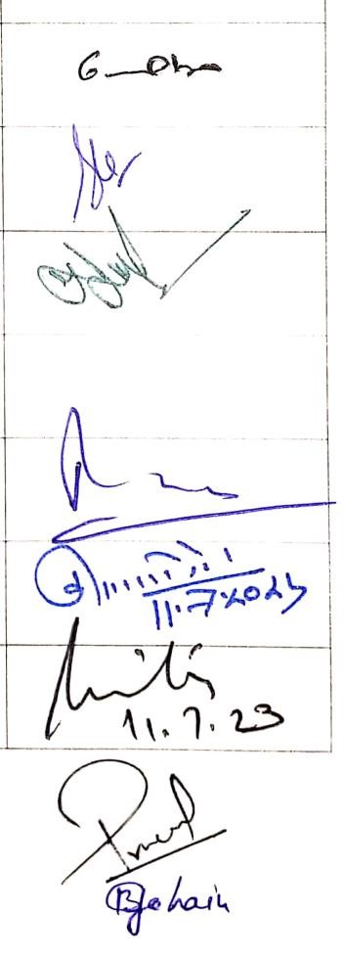
06 | Prof. Kuldeep Singh Negi | PG Principal
07 | Prof. Anita Rawat | Director USERC
08 | Dr Pramod Kumar Anthwal | Faculty Member
09 | Dr Biraj Borgohain | Faculty Member

List of Semester-wise Titles of the Papers in
Geology (Environmental Geology)
(Skill Enhancement Course)

Year | Sem. | Course Code | Paper Title | Theory/  Practical | Credits
 |  | CERTIFICATE COURSE IN SCIENCE
FIRST YEAR | I |  | Level1: Elementary Environmental Geology | Theory | 3
 | II |  | Level 2: Natural Resources | Theory | 3
SECOND YEAR | III |  | Level 3: Earth Processes and Disasters | Theory | 3
 | IV |  | Level 4: Environmental Problems and  Mitigation | Theory | 3

Semester I
Skill Enhancement Course in Geology

Vocational Course (SEC): Environmental Geology

UG First Semester: Level1: Elementary Environmental Geology
Course type,  paper &  Credits | Content | Teaching hours
UG First  Semester:  Level1:  Elementary  Environmental  Geology | Unit I: Concept and classification of environmental geology. | 15
 | Unit II: Earth system and biosphere, man and environment, Ecosystem, Concept of biodiversity. | 15
 | Unit III: Environmental problems, spectrum of environmental geology. | 15

Semester II
Skill Enhancement Course in Geology

Vocational Course (SEC): Environmental Geology
 | UG Second Semester: Level 2: Natural Resources
Course type,  paper &  Credits | Content | Teaching hours
UG Second Semester: Level 2:  Natural  Resources | Unit I: Natural Resources: forests, land and land use, soils, water. | 15
 | Unit II: Elementary idea about non renewable energy resources:  economic minerals, coal and Petroleum. | 15
 | Unit III: Elementary idea about renewable energy resources. Wind Energy, Solar energy, geothermal Energy, Hydropower, Biomass energy. | 15

Semester III
Skill Enhancement Course in Geology

Vocational Course (SEC): Environmental Geology
UG Third Semester: Level 3: Earth Processes and Disasters
Course type,  paper &  Credits | Content | Teaching hours
UG Third  Semester:  Level 3:  Earth Processes and Disasters | Unit I: Elementary idea of Lithosphere and Plate Tectonics. Brief idea of Earth processes. | 15
 | Unit II: Hazards: earthquakes, volcanoes, instability of hill slopes, snow avalanches, floods, coastal hazards. | 15
 | Unit III: Natural hazards and their mitigation, | 15

Semester IV
Skill Enhancement Course in Geology

Vocational Course (SEC): Environmental Geology
UG Fourth Semester: Level 4: Environmental Problems and Mitigation
Course type,  paper &  Credits | Content | Teaching hours
UG Fourth Semester:  Level 4:  Environment al Problems and Mitigation | Unit I: Problems of pollution and wastes, urbanization and climate of cities, waste management. | 15
 | Unit II: Biogeochemical factors in environment, human health, disease induced by environment. | 15
 | Unit III: Wasteland management, rural development. | 15

