NATIONAL EDUCATION POLICY-2020

Bachelor of Science (Research)/ Master of Science
(Geology)

Syllabus Minor Elective Subject
Geology
DEPARTMENT OF GEOLOGY
FACULTY OF SCIENCE
SRI DEV SUMAN UTTARAKHAND VISHWAVIDYALAYA

S.No. | Name | Designation | Signature
01 | Prof. G. K. Dhingra | Dean Science
02 | Dr. S. K. Nautiyal | HOD Geology
03 | Prof. Yashpal Sundriyal | Subject Expert
04 | Prof. Pushpa Negi | PG Principal
05 | Prof. Pankaj Pant | PG Principal | 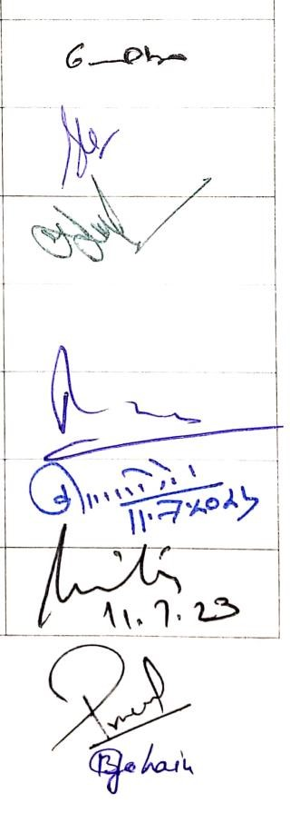
06 | Prof. Kuldeep Singh Negi | PG Principal
07 | Prof. Anita Rawat | Director USERC
08 | Dr Pramod Kumar Anthwal | Faculty Member
09 | Dr Biraj Borgohain | Faculty Member

 |  | List of Semester-wise Titles of the Papers in Geology (Minor Elective Subject)
Year | Sem. | Course Code | Paper  Title | Theory/  Practical | Credits
 |  | BACHELOR OF SCIENCE (RESEARCH)
UG  FOURTH  YEAR/  PG  FIRST  YEAR | VII/I |  | Geology: Integrated Science | Theory | 04
 | VIII/II

PROGRAMME OUTCOMES (POs)

The curricula of geology as a Minor Elective Subject are designed for the students who do not have geology as a Major Elective Subject. It has the following programme outcomes:

PO 1: Enabling the students to understand the basic concepts of the physical components and processes of the earth.

PO 2: Enabling the students to understand the importance of the other branches of science in studying the evolutionary processes of the earth in spatio-temporal concept.

PO 3: Enabling students to application potential of the other branches of science in understanding physical and historical development of the earth..

Programme specific outcomes (PSOs):

PSOs: The subject of geology in Bachelor of Science (Research)/ Master of Science (Geology) programme pertains to broad physical aspects of the earth. This programme will make understand the students as to how the integration of knowledge obtained through different branches of science helps understand the physical characteristics and processes of the
earth. The knowledge gained through this programme will enhance the students understanding about application potential of the different branches of science in studying the spatio-temporal evolution of the planet earth.

Semester I/II
Paper: Geology: Integrated Science

Course outcome: After successful completion of this course students will have basic knowledge of the physical characteristics and processes of the earth. The students will be able to apply the knowledge they gained in other branches of science in better understanding the earth’s evolutionary processes as well as evolution of life on it.
Course type, paper & credit | Content | Teaching hours
Theory  Geology: Integrated  Science  (04) | Unit 1: The basic concepts about the origin and evolution of igneous, sedimentary and metamorphic rocks. Deformation of rocks and resultant major geological structures in the solid earth.  Geomorphic processes and resultant landforms.. | 15
 | Unit II: Earth’s geochemical differentiation. Geochemical classification of elements and how does it differ from periodic classification of elements. Minerals as a building block of the rocks. Classification and structure of silicate minerals. Geochemical environment near Earth’s surface. | 15
 | Unit III: The seismic waves and its application in understanding the interior of the Earth. Magnetic properties of rocks; Classification of rocks in terms of petrophysics. Earthquakes and its mitigation.  Elementary knowledge of geophysical exploration. | 15
 | Unit IV: Geological time scale; Fossils and its modes of preservation; Evolution of life in the geological past; Basic principles of stratigraphy. Microfossils and its application in the exploration of oil and natural gas. | 15

Suggested Reading:
- Arthur Holmes (1992). Principles of Physical Geology. Chapman and Hall, London.
- R. J. Park (1998) Foundation of Structural Geology, III Edition, Routledge.
- Davis, G.H. (1984). Structural Geology of Rocks and Region. John Wiley.
- Ghosh, S.K.(1995). Structural Geology: Fundamentals of Modern Development. Pergamon.
- Albarde Francis (2003).Geochemistry Introduction. Cambridge University Press
- Allegre, C.J. and Michard,G. (1974). Introduction to Geochemistry, Reidel, Holland
- Berry, L.G., Mason,B. and Dietrich, R.V.(1982). Mineralogy. CBS Publ.
- Dana, E.S. and Ford, W.E.(2002). A textbook of Mineralogy (Reprint)
- Ehlers, W.G. and Blatt,H.(1987). Petrology, Igneous, Sedimentary and Metamorphic rocks, CBS Publishers.
- Blatt,H., Middleton, G.V.and Murray,R.C.(1980).Origin of sedimentary rocks. Prentice Hall Inc
- Storetvedt, K.N.(1997).Our Evolving Planet: Earth’s History in New
Perspective-Bergen(Norway),Alma Mater Fortag
- Keary,P. and Vine, F.J.(1990). Global Tectonics-Balckwell Publishing.
- Turcotte,D.L and Schubert,G.(2002). Geodyanamics, second edition., Cambridge University Press.
- Best, M.G. (2002) Igneous and Metamorphic Petrology. II Edition, WileyBlackwell
- Schrock,Twenhofel and Williams(1953). Principles of Invertebrate Paleontology. CBS, Delhi.
- Bilal U. Haq andA. Boersome, Introduction to Marine Micropaleontology
- Ravindra Kumar (1985). Fundamentals of Historical Geology & Stratigraphy of India. Wiley Eastern.

.
Suggested Online Link:

- https://www.mooc-list.com/course/mountains-101-coursera
- https://www.mooc-list.com/course/planet-earth-and-you-coursera
- https://www.mooc-list.com/course/dynamic-earth-course-educatorscoursera
- https://www.classcentral.com/course/swayam-structural-geology-14312
- https://www.classcentral.com/course/swayam-petrology-14084
- https://www.classcentral.com/course/swayam-geology- metamorphicpetrology-thermodynamics-22994

