NATIONAL EDUCATION POLICY-2020

Bachelor of Science (Research)/ Master of Science (Geology)

Syllabus Industrial Training/ Survey/Research Project

DEPARTMENT OF GEOLOGY
FACULTY OF SCIENCE
SRI DEV SUMAN UTTARAKHAND VISHWAVIDYALAYA

S.No. | Name | Designation | Signature
01 | Prof. G. K. Dhingra | Dean Science
02 | Dr. S. K. Nautiyal | HOD Geology
03 | Prof. Yashpal Sundriyal | Subject Expert
04 | Prof. Pushpa Negi | PG Principal
05 | Prof. Pankaj Pant | PG Principal | 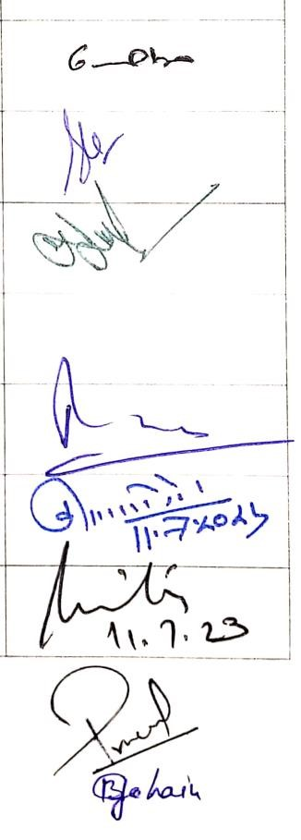
06 | Prof. Kuldeep Singh Negi | PG Principal
07 | Prof. Anita Rawat | Director USERC
08 | Dr Pramod Kumar Anthwal | Faculty Member
09 | Dr Biraj Borgohain | Faculty Member

 | Industrial Training/ Survey/Research Project
Year | Sem. | Course  Code | Paper  Title | Credits
 | Bachelor (Research) of Science (Geology)
UG  Fourth  Year  /PG  FIRST  YEAR | VII/I |  | Training on Geological Sampling | 4
 | VIII/II |  | Training on Geological Sample  Preparation | 4
 | Master of Science (Geology)
UG Fifth  Year  /PG  SECOND  YEAR | IX/III |  | Training on Instrumentation in  Geological Investigation | 4
 | X/IV |  | Training on Geotechnical  Investigations and Report Writing | 4
FIRST YEAR

Semester I
Paper: Training on Geological Sampling

Course outcome: Geological investigations involve field observation and laboratory treatment. The geoscientific hypothesis is primarily framed on the basis of field observations and tested further through laboratory investigation. Many data thus generated in the field and laboratories rely more on the nature and type of geological investigation, knowledge on the field area, use of appropriate technique and methods for data collection and sampling in the field for further laboratory treatment. This course will impart hands-on training on field data and sample collection for specific type of geological investigations.
Course type,  paper& Credits | Content | Training hours
Field training | The paper will be based on geological field training, in which the students will be trained on the following aspects: | 120
Geological Sampling  (04) | - Site selection for sampling.  - Sample collection for Thin Section Preparation, Rock Powder Preparation, Groundwater analysis, different types of dating.  - Archiving of collected samples  (Note: Marks will be evaluated on the basis of student’s field training report.)

FIRST YEAR
Semester II
Paper: Training on Geological Sample Preparation

Course outcome: Geological investigations in laboratories involve use of appropriate technique and method of sample preparation with a specific objective. This course will therefore impart hands-on training on the preparation of samples for a specific type of laboratory investigation.
Course type, paper&  Credits | Conte nt | Trainin g hours
Laboratory training  Geological Sampling  (04) | The paper will be based on laboratory training on sample preparation, in which the students will be trained on the following aspects:  - Preparation of rock and mineral thin sections for petrographic, modal and microstructural analyses.  - Mineral separation techniques  - Powdering the samples for geochemical analysis.  - Preparation of water samples for chemical analysis  - Archiving the prepared samples  (Note: Marks will be evaluated on the basis of student’s laboratory training report.) | 120
SECOND YEAR

Semester III
Paper: Training on Instrumentation in Geological Investigations

Course outcome: Many laboratory investigations in geology require the use of instruments, that are often quite expensive and sophisticated. Knowing the capability and sequence of procedures (SOP) of a particular instrument, safety measures and precautions in its operation, as well as knowing the maintenance aspects is imperative for the proper functioning and getting the reliable and accurate results. This course will impart hands-on training and safe operation of the common instruments used for analyzing the geological samples.
Course type, paper& Credits | Content | Training hours
Laboratory training | The paper will be based on laboratory training, in which the students will be trained on the following aspects: | 120
Geological Sampling  (04) | - Setting, handling, and making use of stereo zoom and petrological microscopes under transmitted and reflected lights, and use of software for microphotography, scaling and image analysis.  - Handling and operating the high-end equipments like SEM-CL-EDAX, and WDXRF, AAS, etc.  (Note: Marks will be evaluated on the basis of student’s laboratory training report.)
Semester IV
Paper: Training on Geotechnical Investigations and
Report Writing

Course outcome: Irrespective of specialization, a professional geologist is required to conduct geotechnical investigations at different sites where civil engineering projects are present/planned to come-up, or where the society is being/has potential to be affected by high-energy dynamic geological processes like landslides, floods, glacial avalanches, earthquakes, volcanism etc. A geologist’s report in all such situations provides the important baseline geoscientific and geotechnical information, based on which appropriate structural and civil measures for the safety and security of the society are taken-up. This course will impart basic training on this aspect of the geological investigations.
Course type, paper&  Credits | Conte nt | Trainin g hours
Field training | The paper will be based on field and laboratory training, in which the students will be trained on the following aspects: | 120
Geological Sampling  (04) | - Conducting geotechnical investigations in specific field site under stress of geological processes, or of proposed social and civil engineering projects.  - Writing the report easily understandable to the geology and non-geology experts.  (Note: Marks will be evaluated on the basis of student’s Field training report.)

